1. Screen header/title name not display properly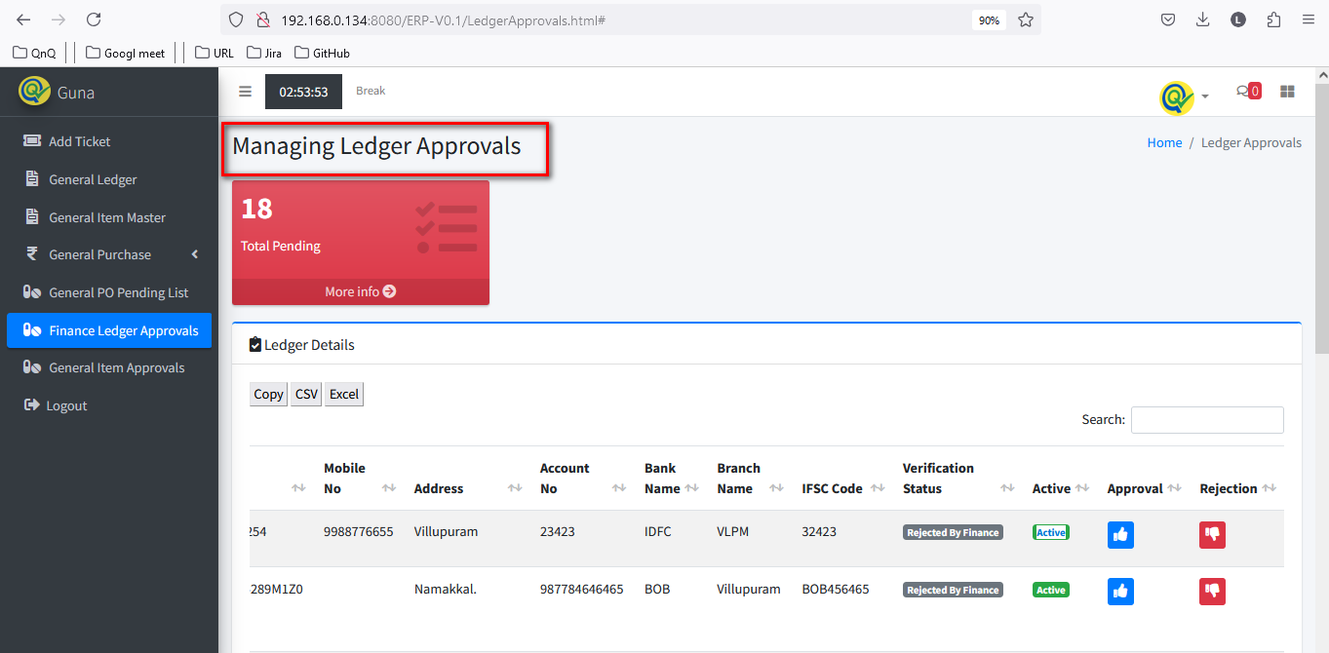

//

2. Mismatch menu icon name display for Finance Ledger Approval 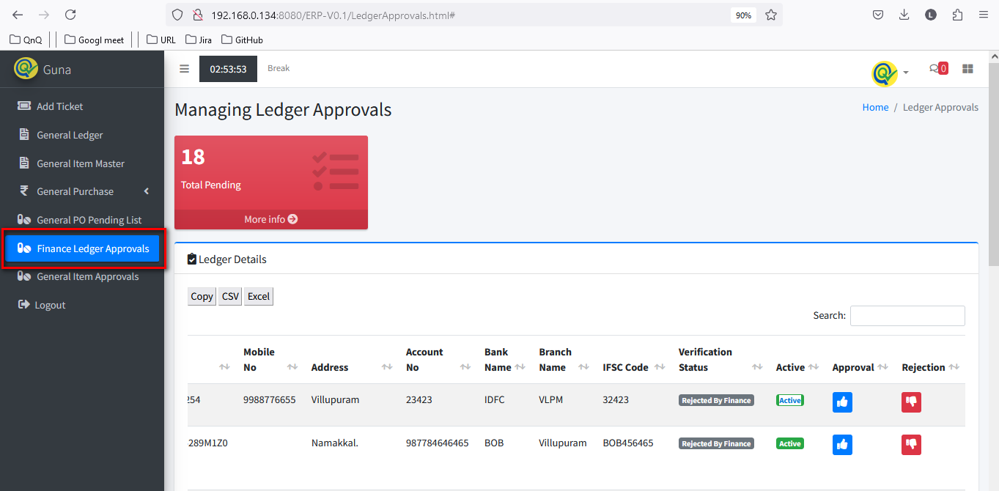

//

3. Mismatch menu icon display for Finance Ledger Approval 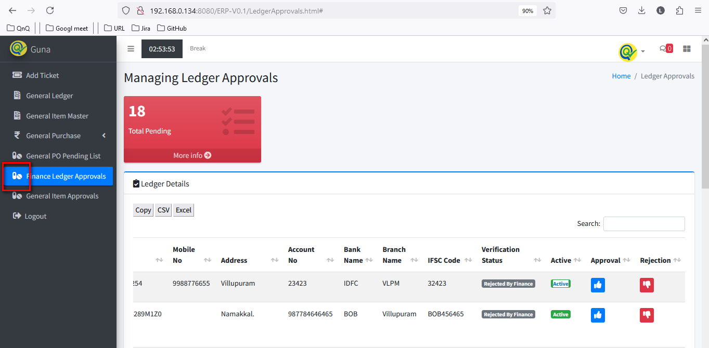

//

4. Navigation section display mismatch value 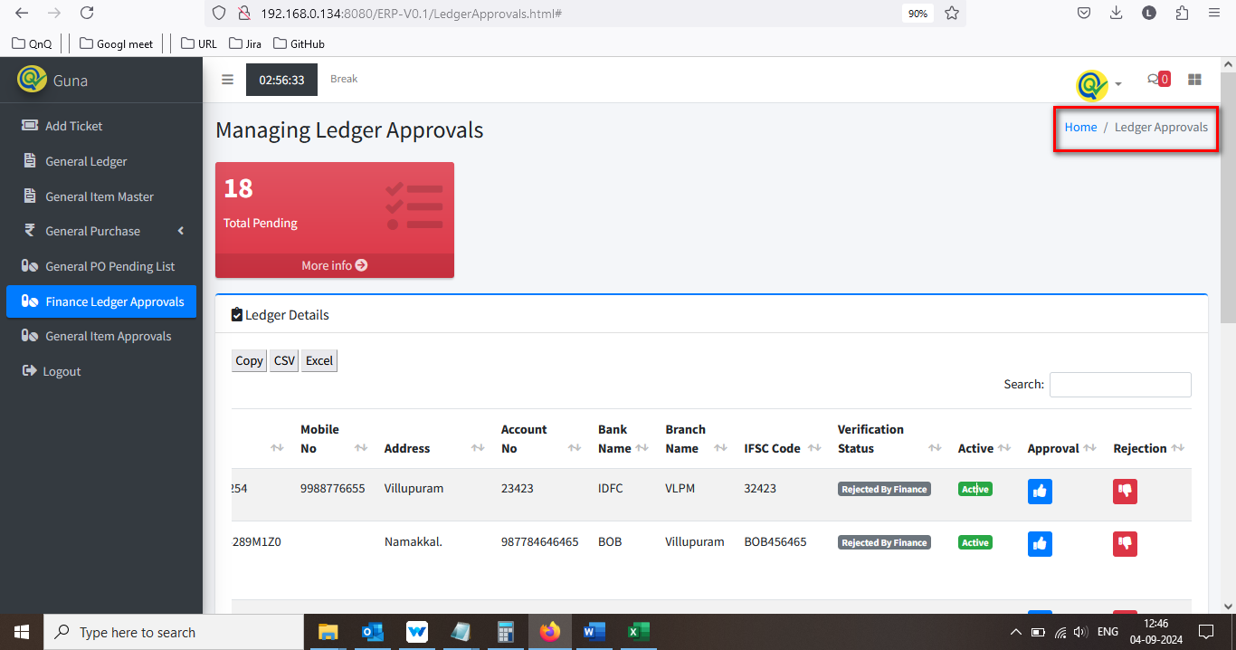

//

5. Confirmation message not display while click the approve button 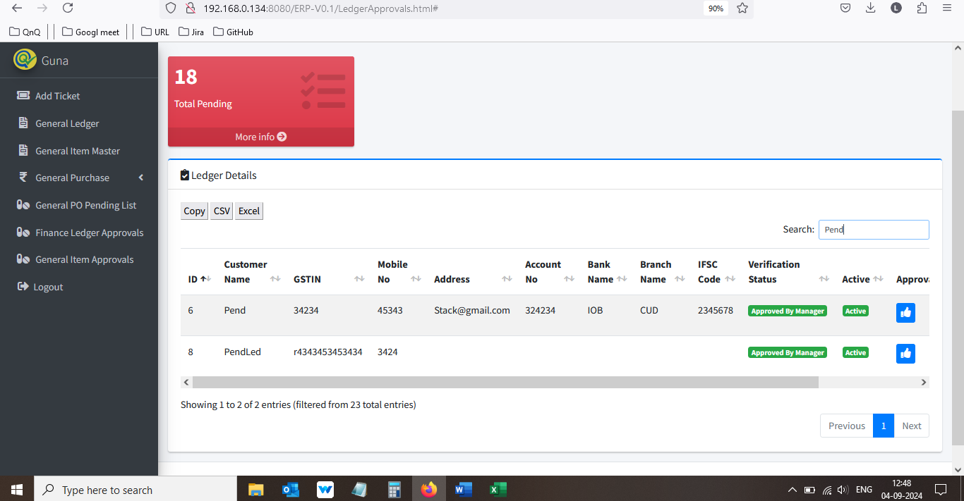 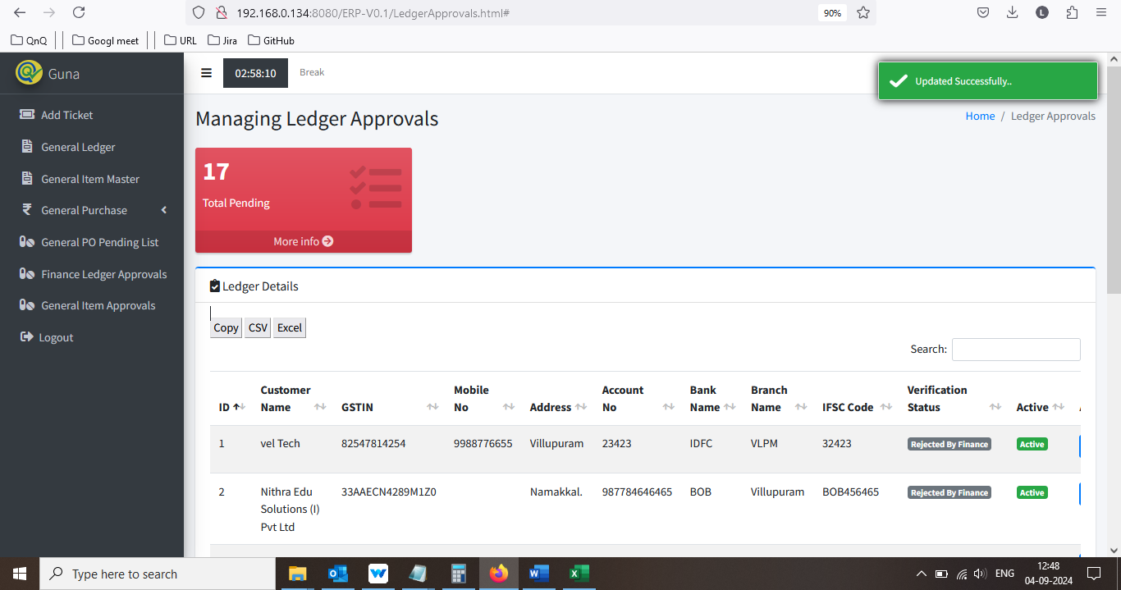

//

6. Placeholder or inner text not display in Search filter text box 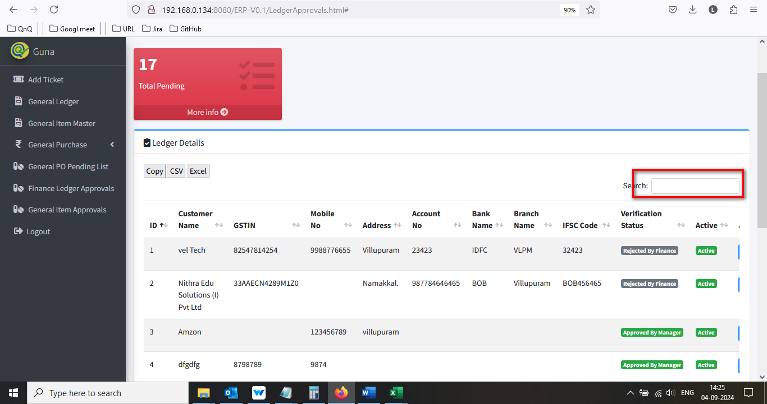

//

7. Icon's not display in download option section 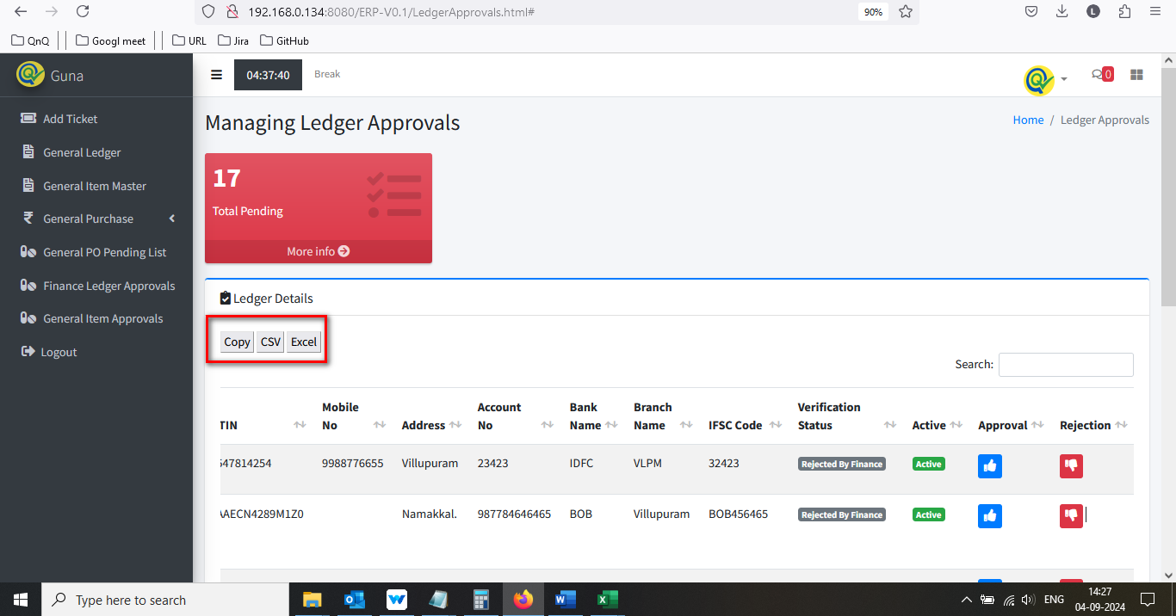

//

8. List grid display Improper border alignment 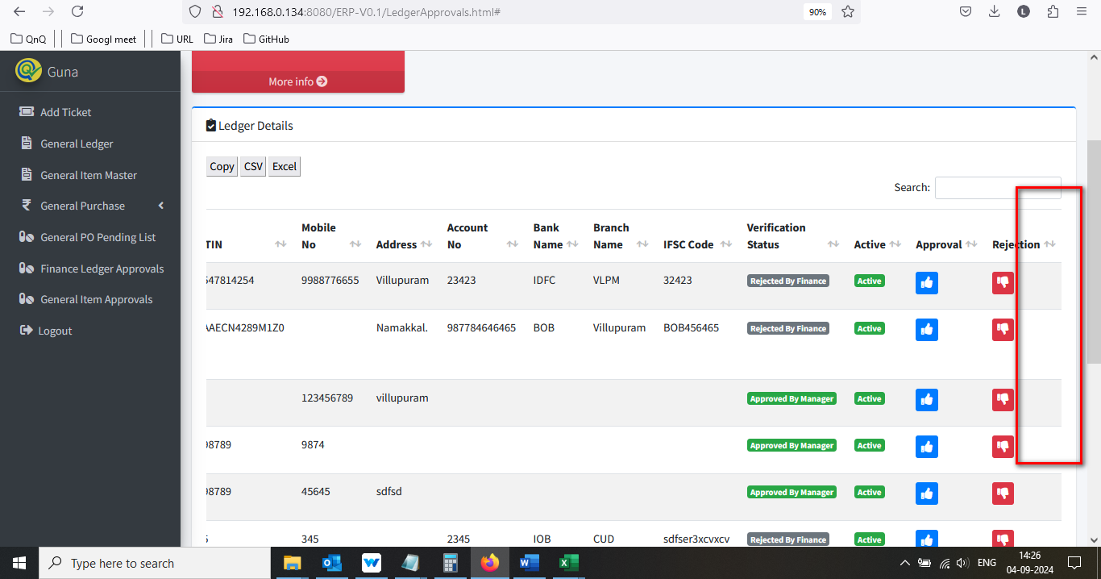

//

9. Unwanted column display in Item list grid 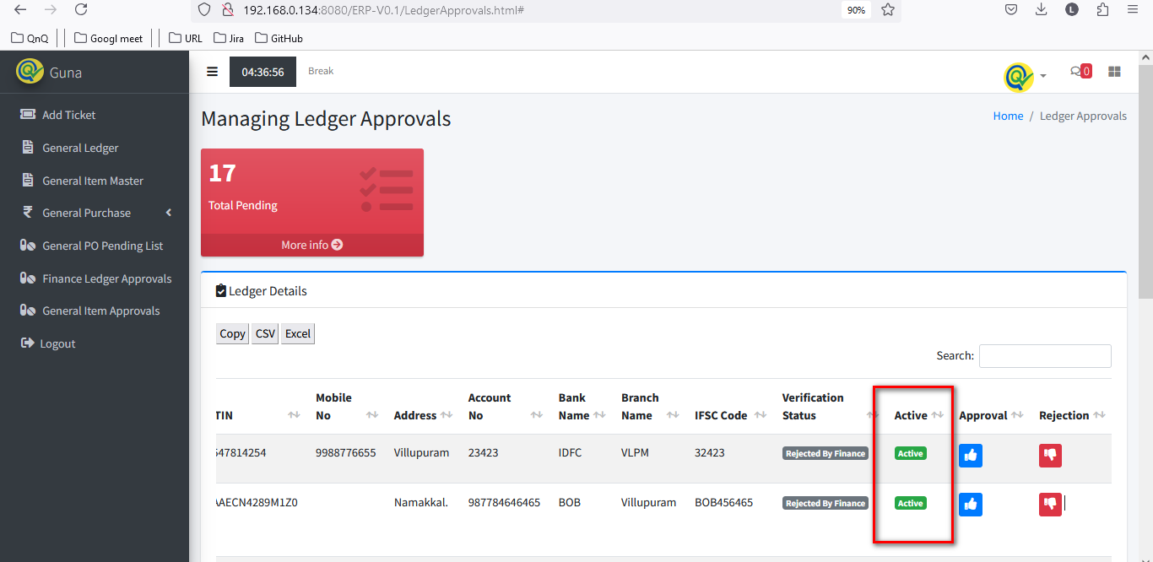

//

10. Icon’s not display in middle of the column 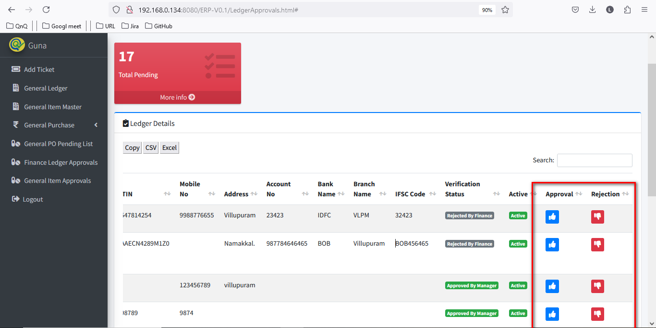

//

11. Column separator highlighted line not display in list grid 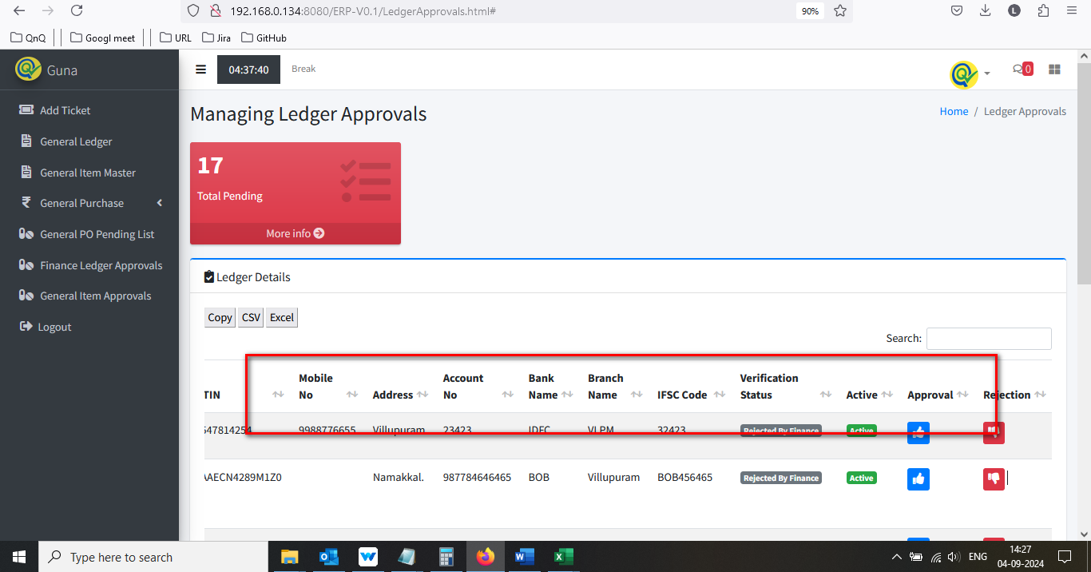

//

12. Sort icon display as too small 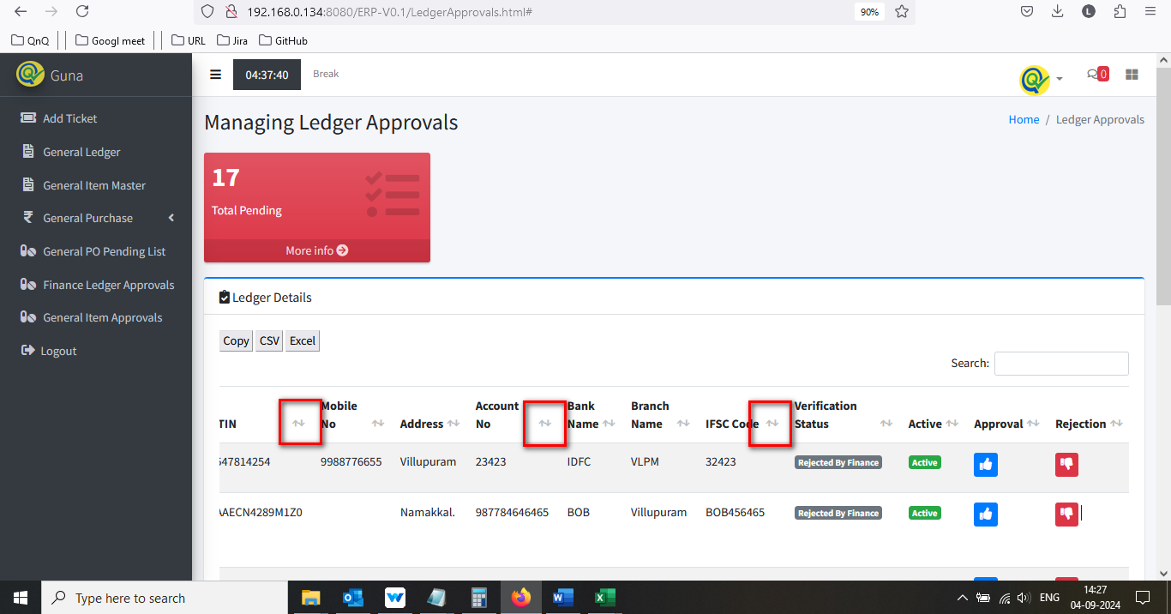

//

13. More info button not working 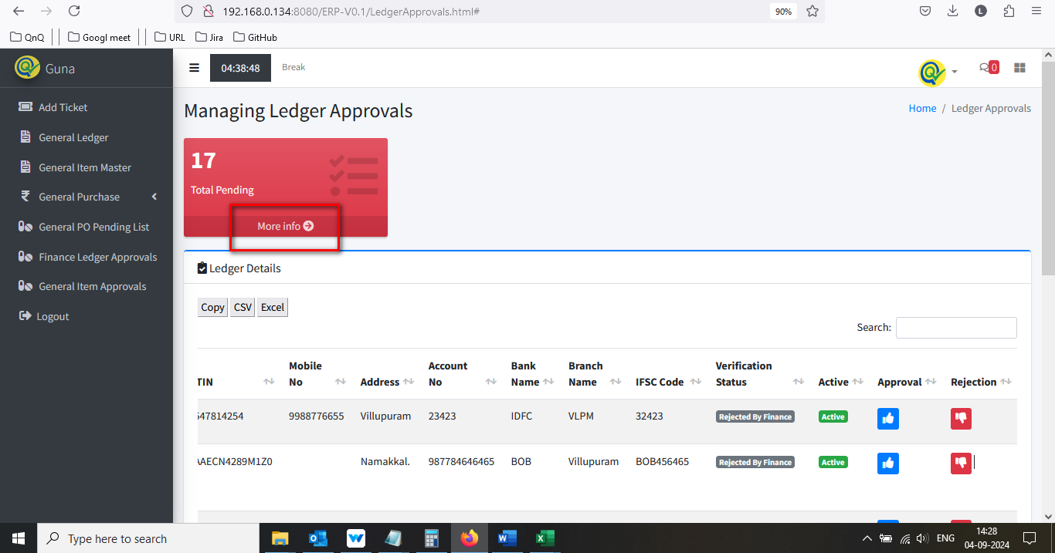

//

14. Improper alignment display in list grid while maximum value 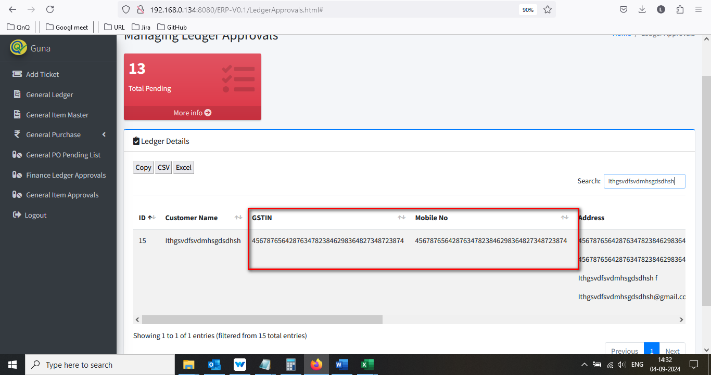

//

15. Required error message not getting display while skip/click the submit button 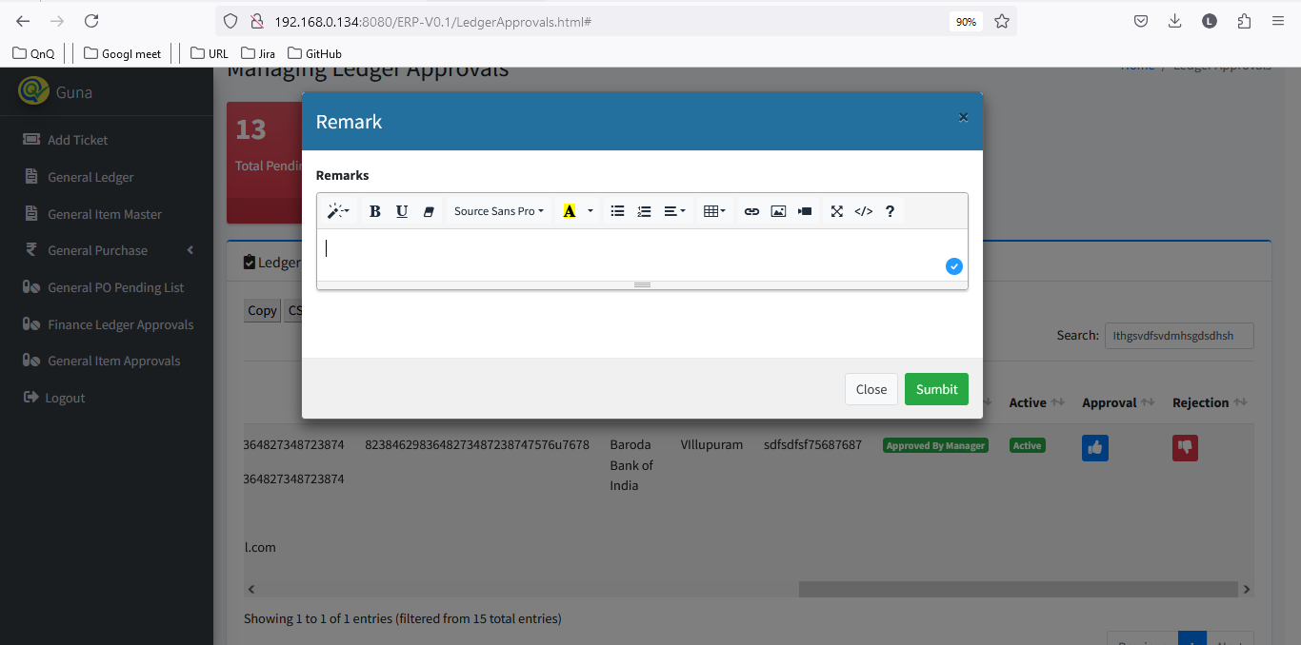 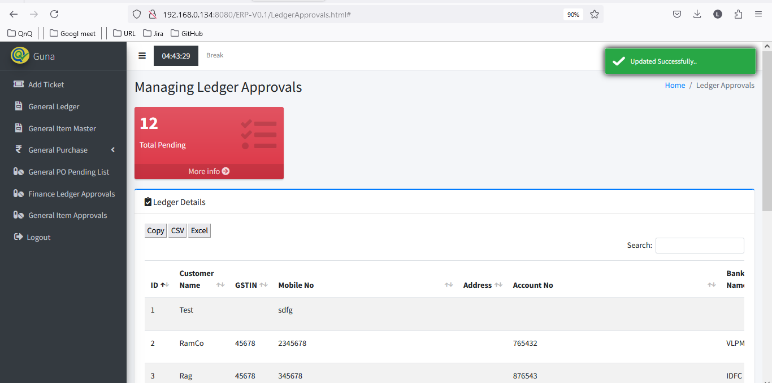

//

16. Values display in remarks fields while click Reject icon 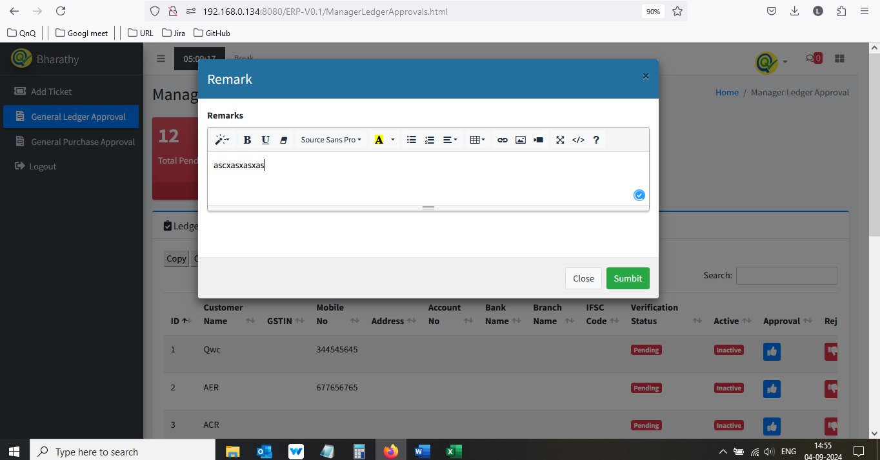 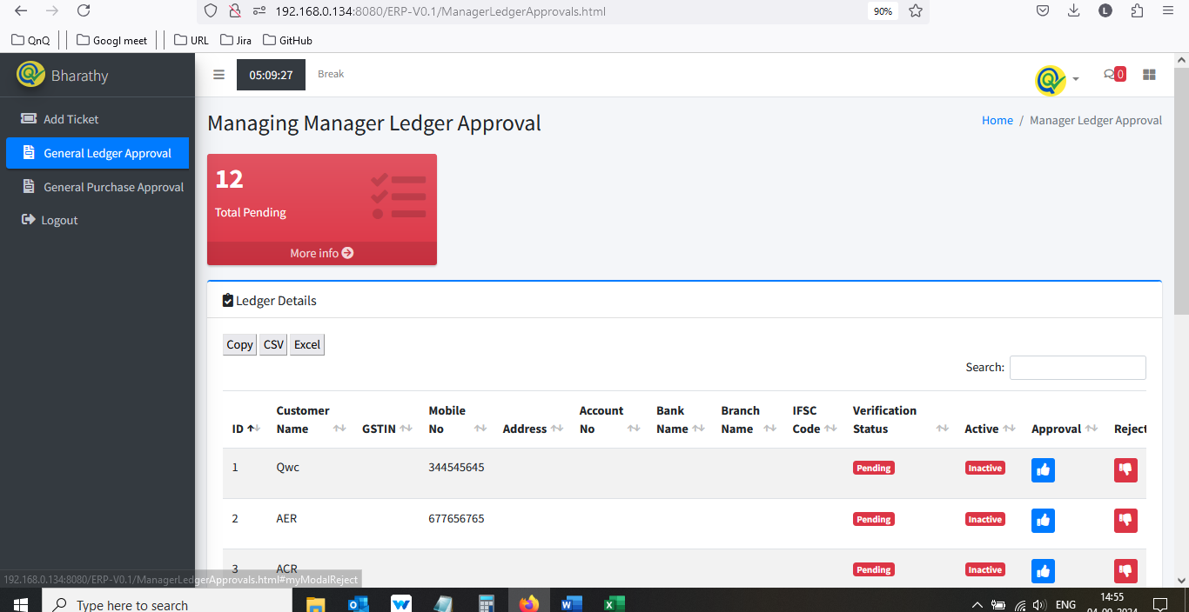 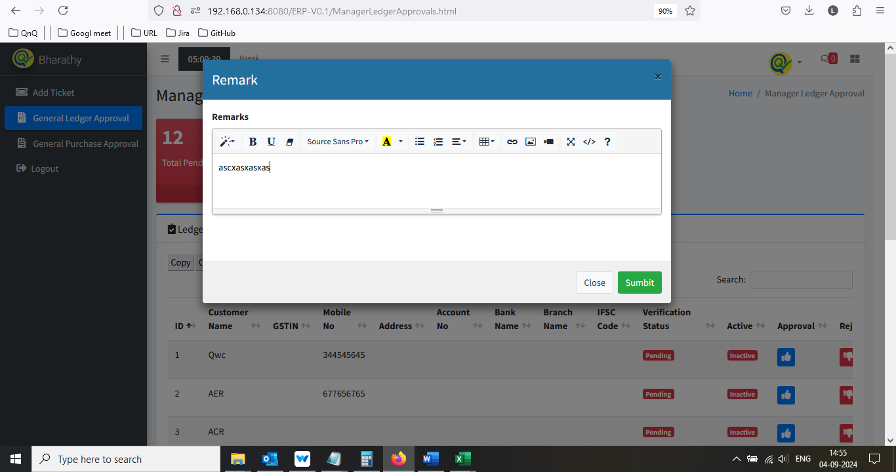

//

17. Mismatch pop up title display 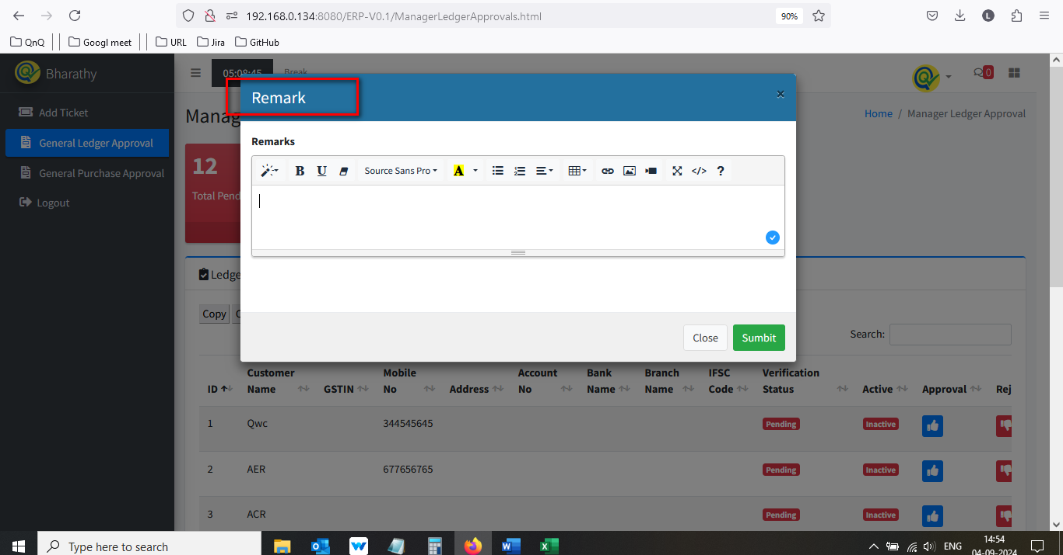

//

18. Close icon not display properly 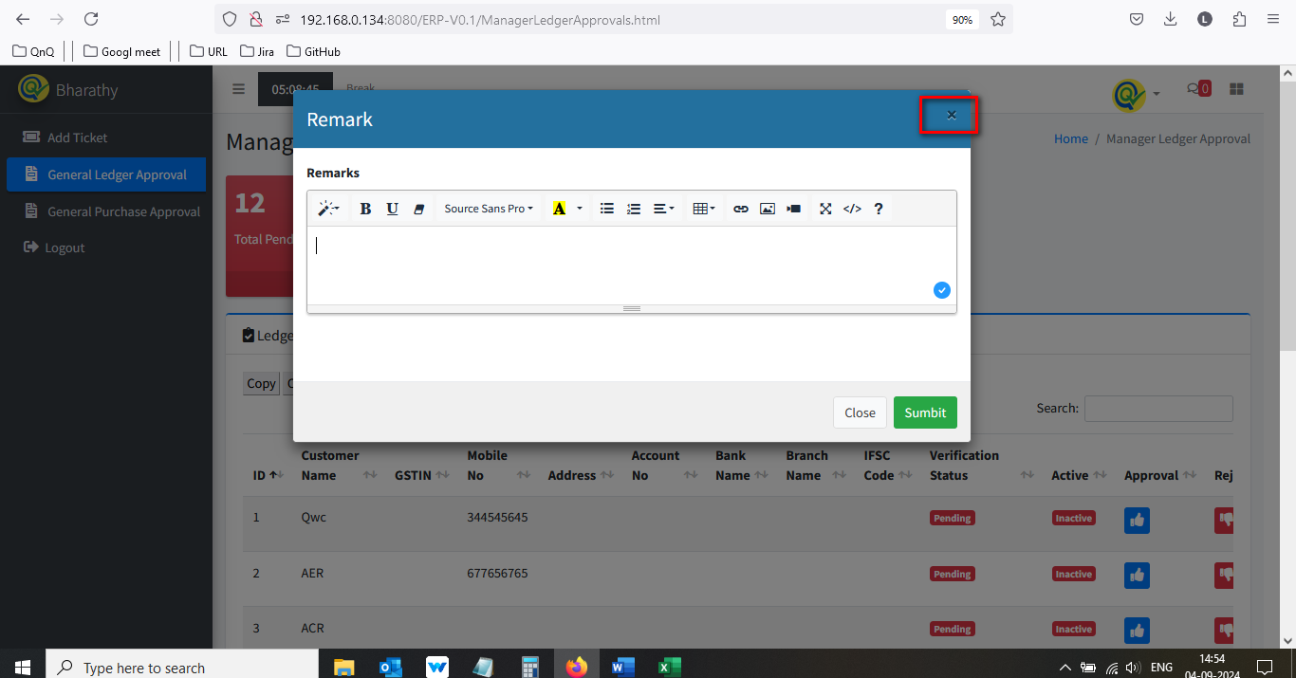

//

19. Confirmation message not display while close the pop up with all values 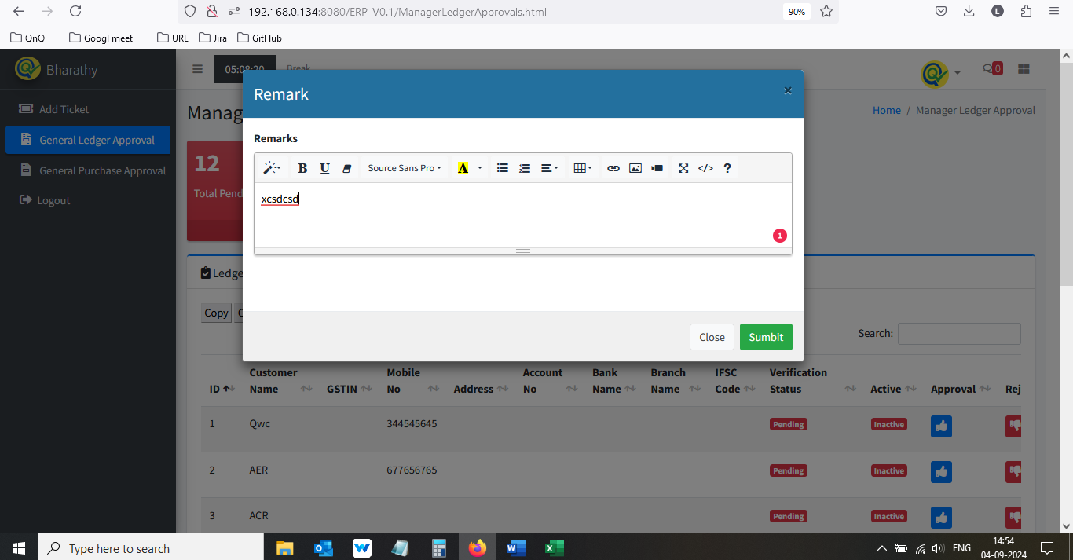 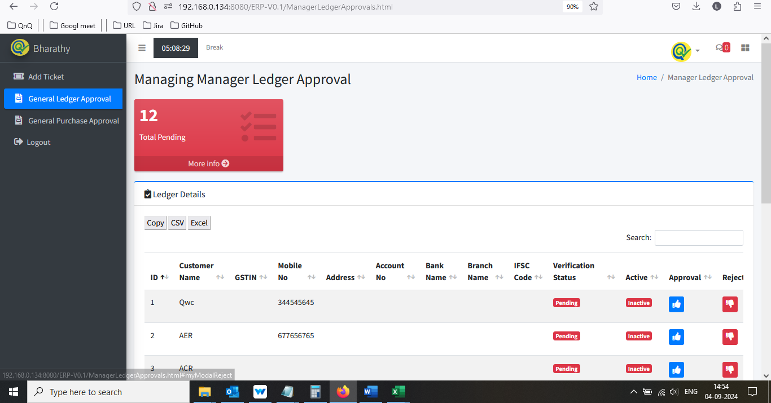

//

20. Rejection up getting close while click beyond the pop up 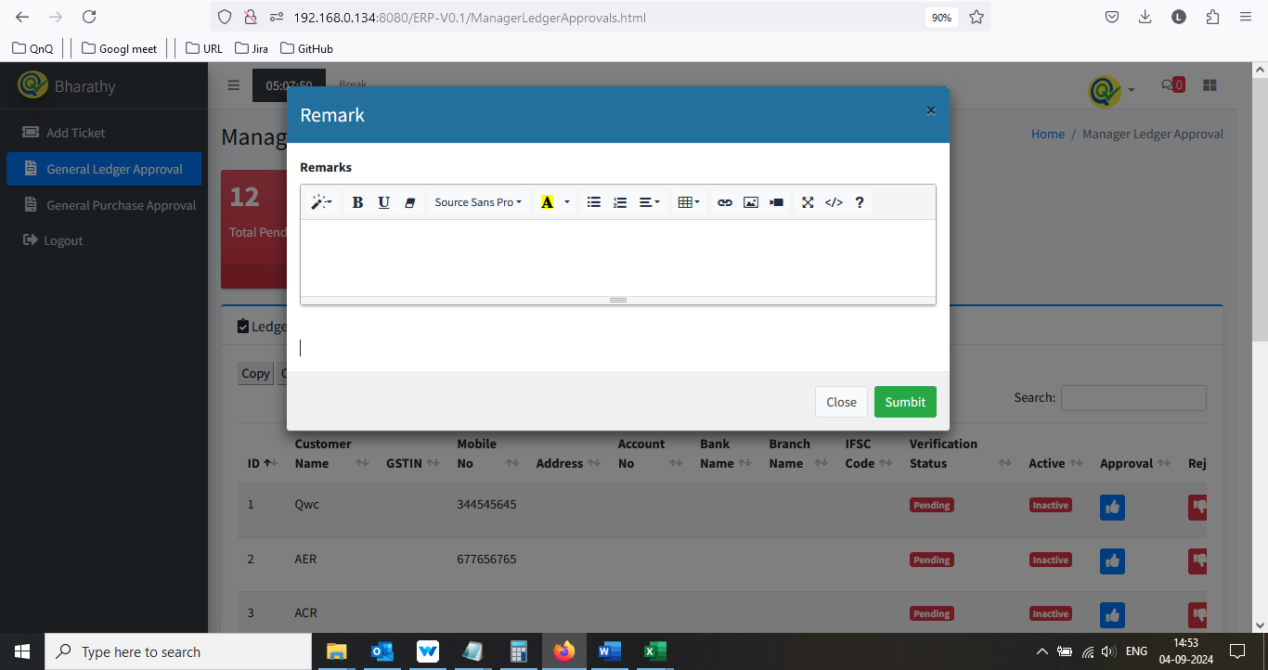 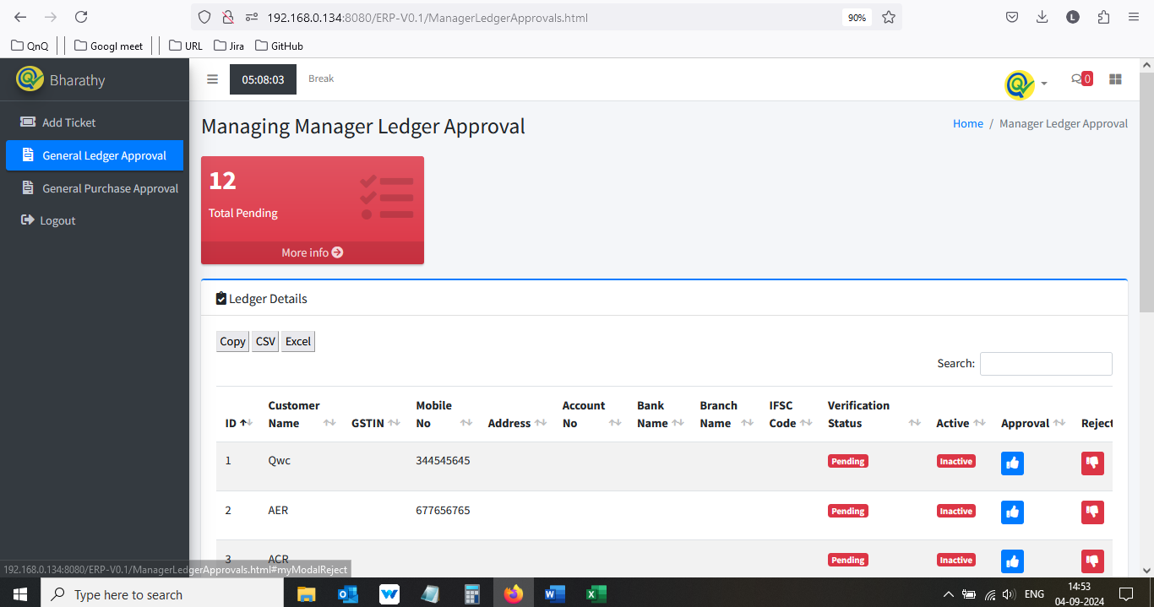

//

21. Remarks field display resized alignment, while click the Reject Icon 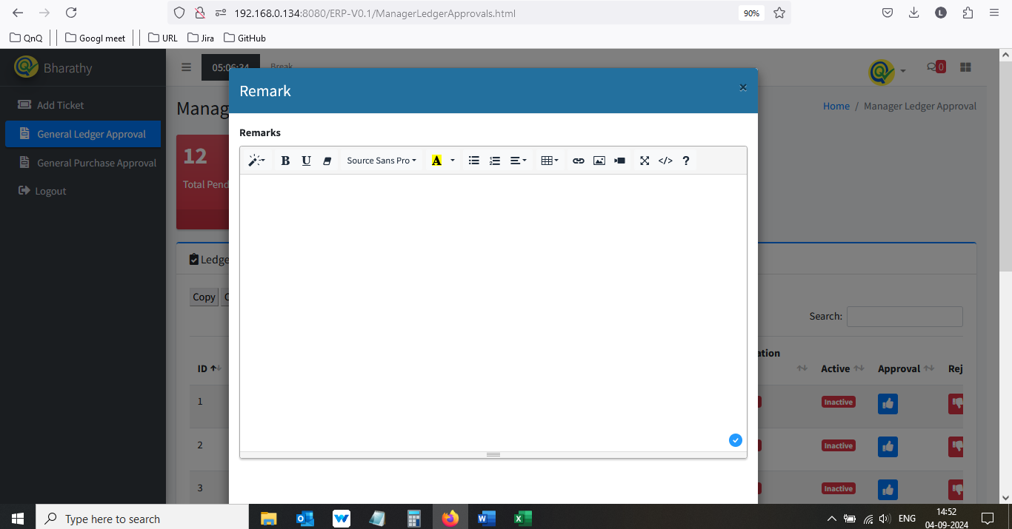 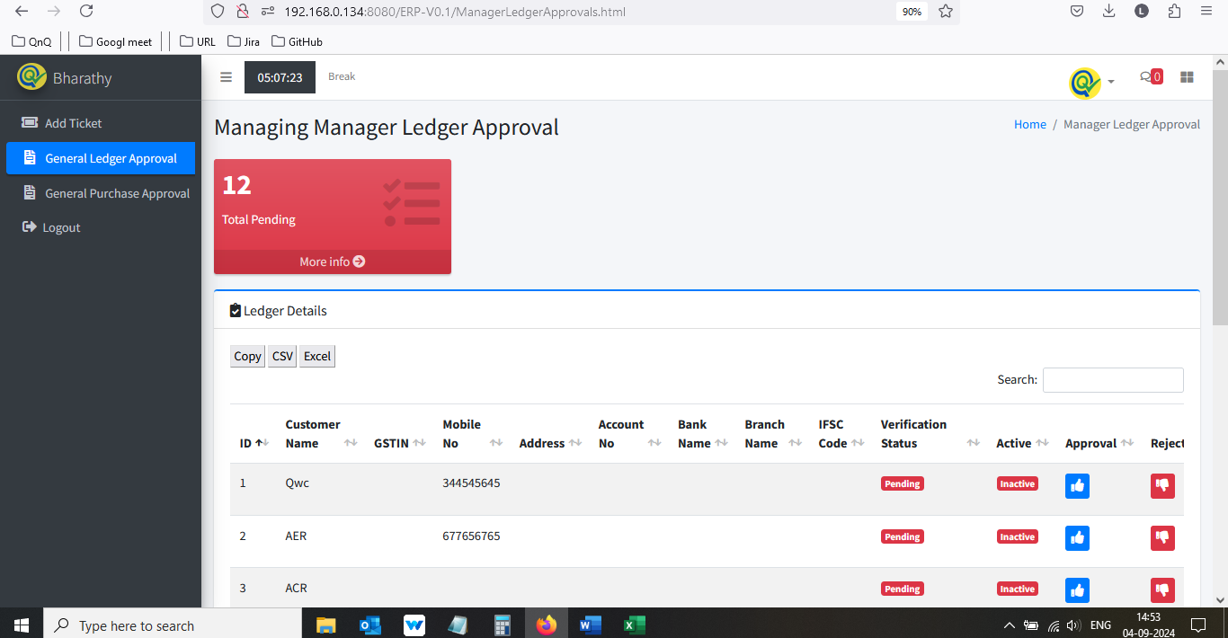 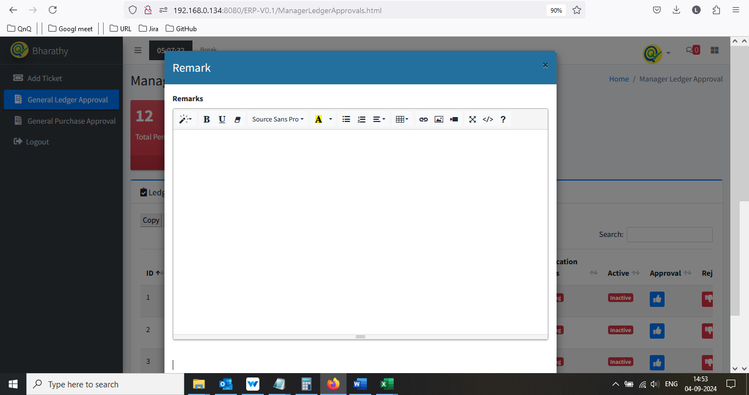

//

22. Tool tip not display for Close icon 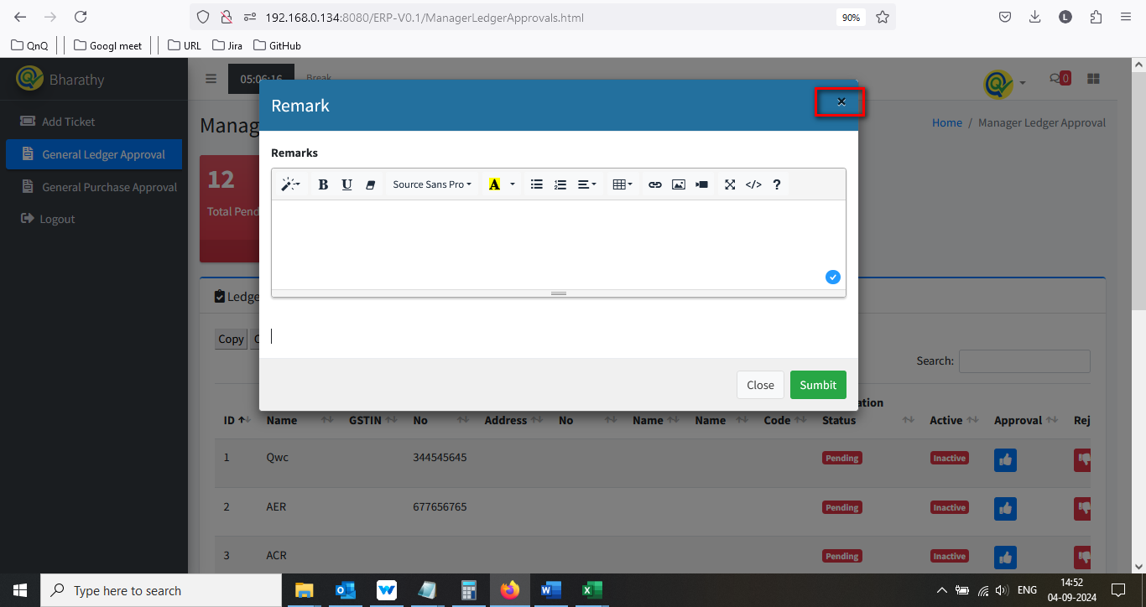

//

23. Placeholder or inner text not display in Remarks field 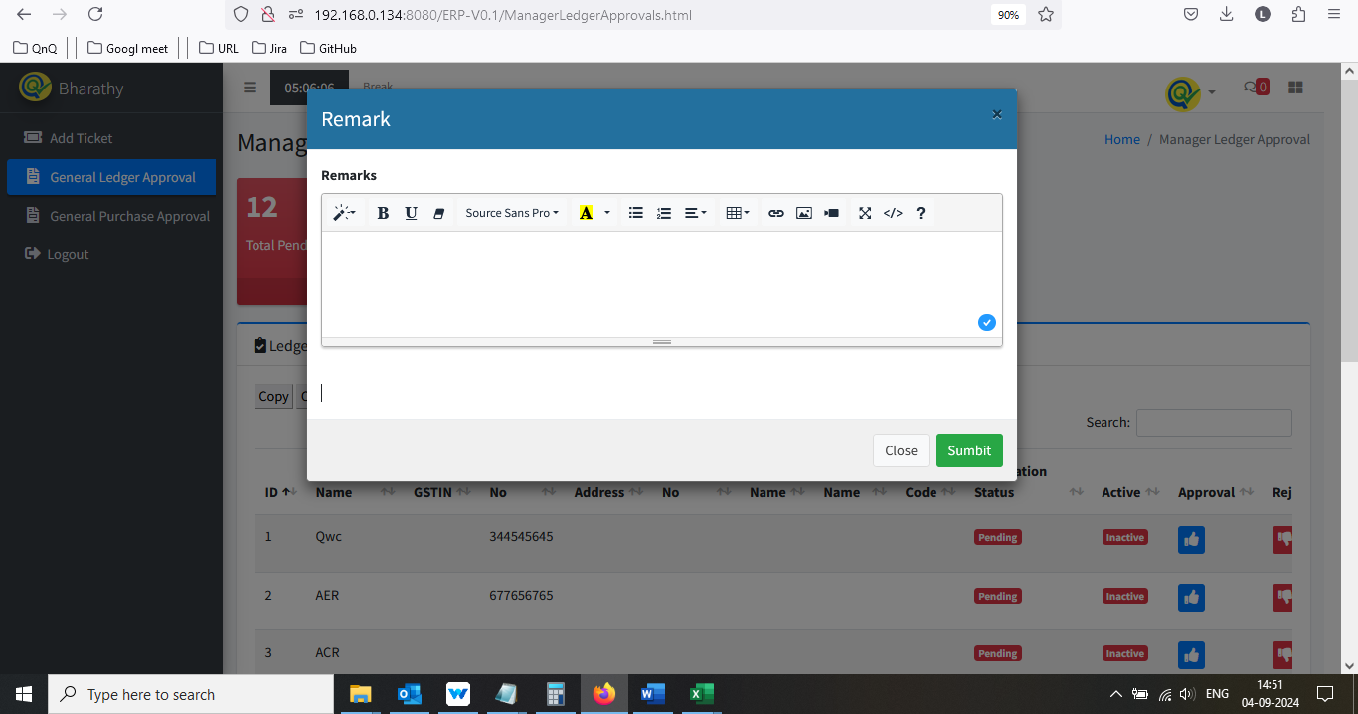

//

24. Error message display while click submit button with insert image in remarks field 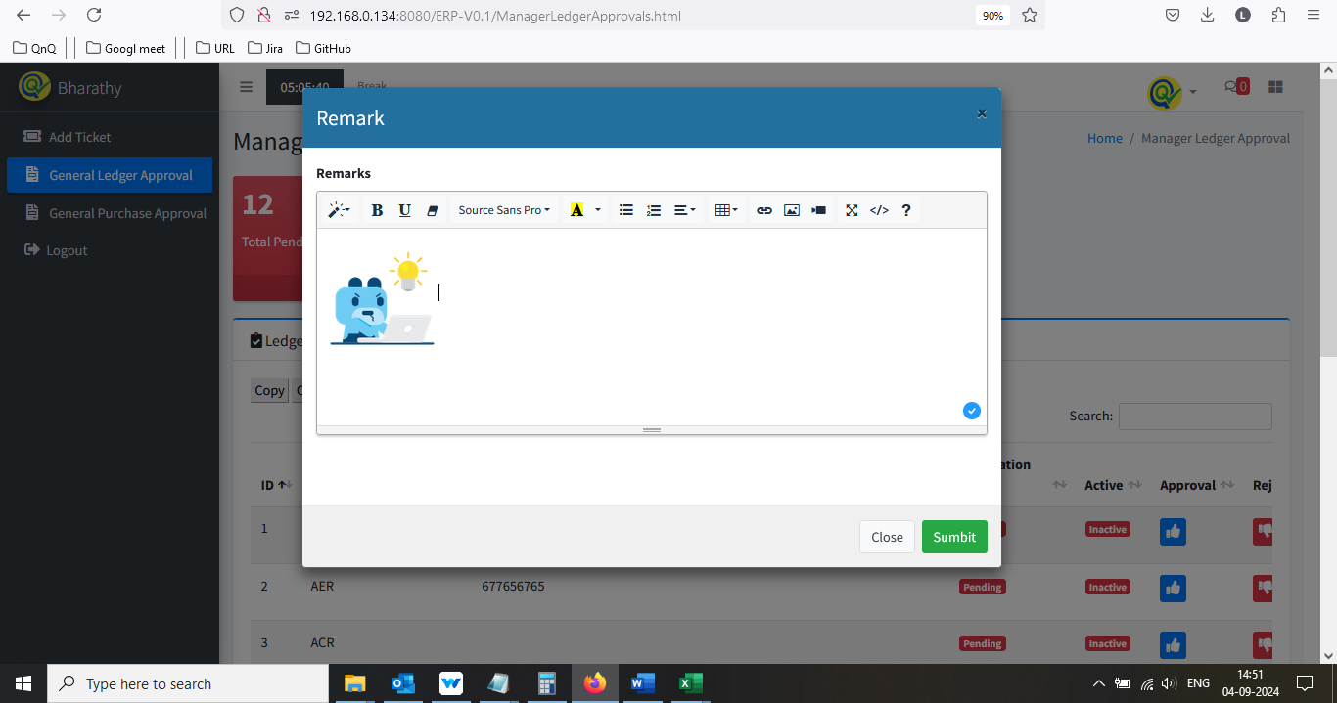 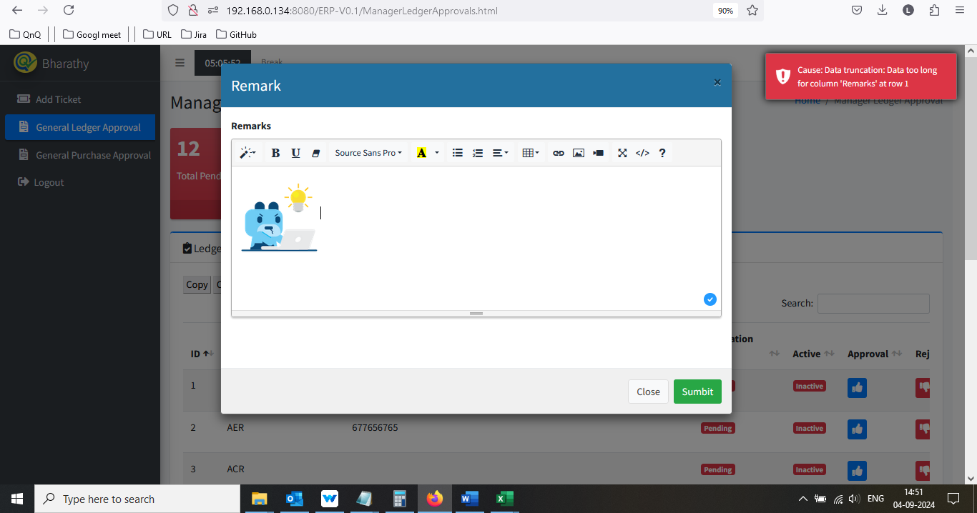

//

25. UI getting collapse while click code view button 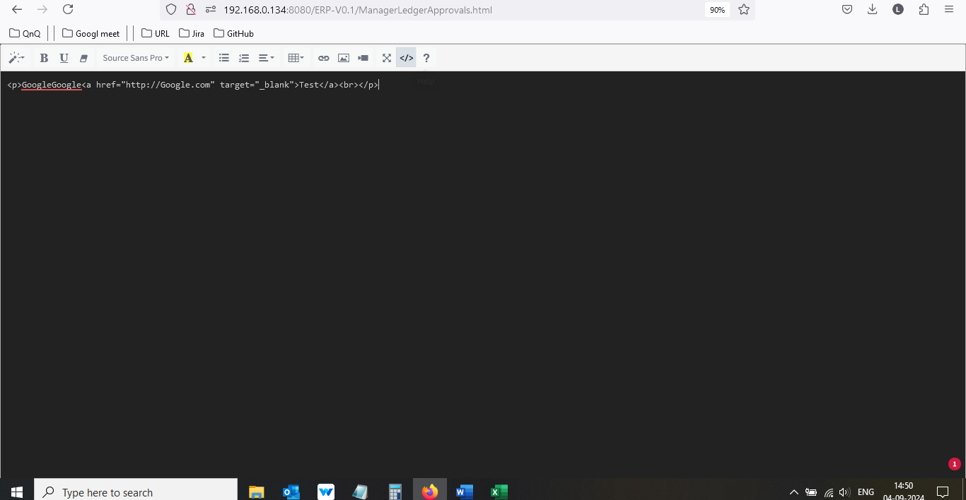 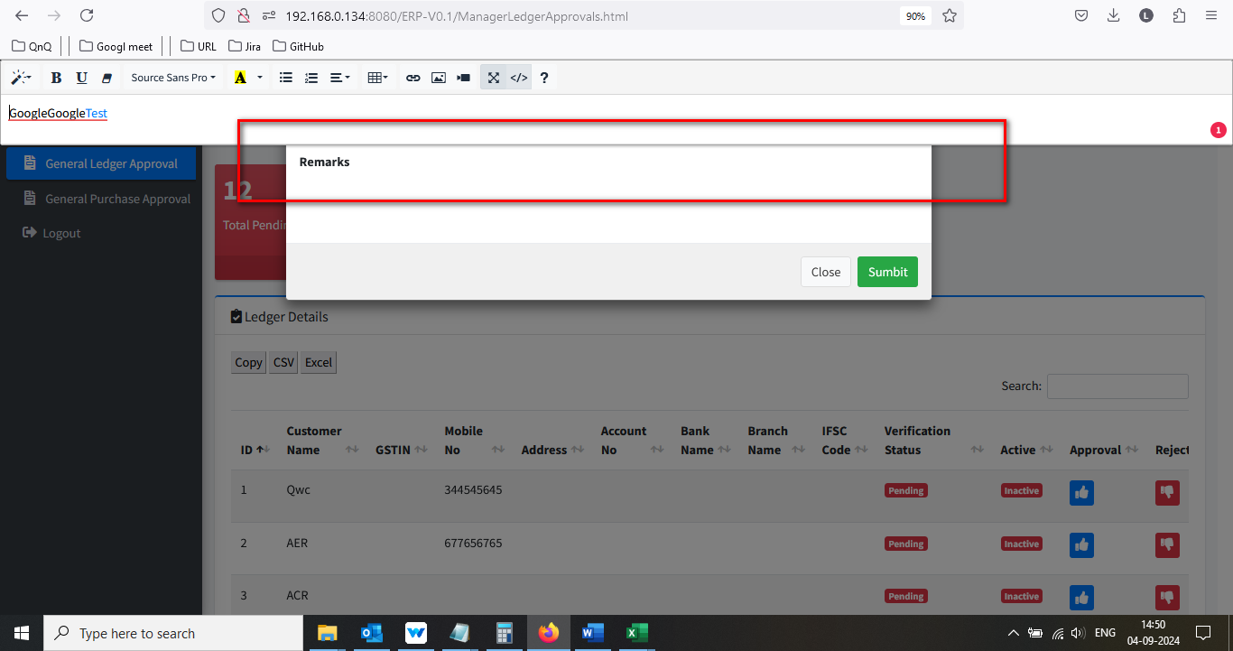

//

26. Reject pop up getting close while close the Video/Image/Link pop up 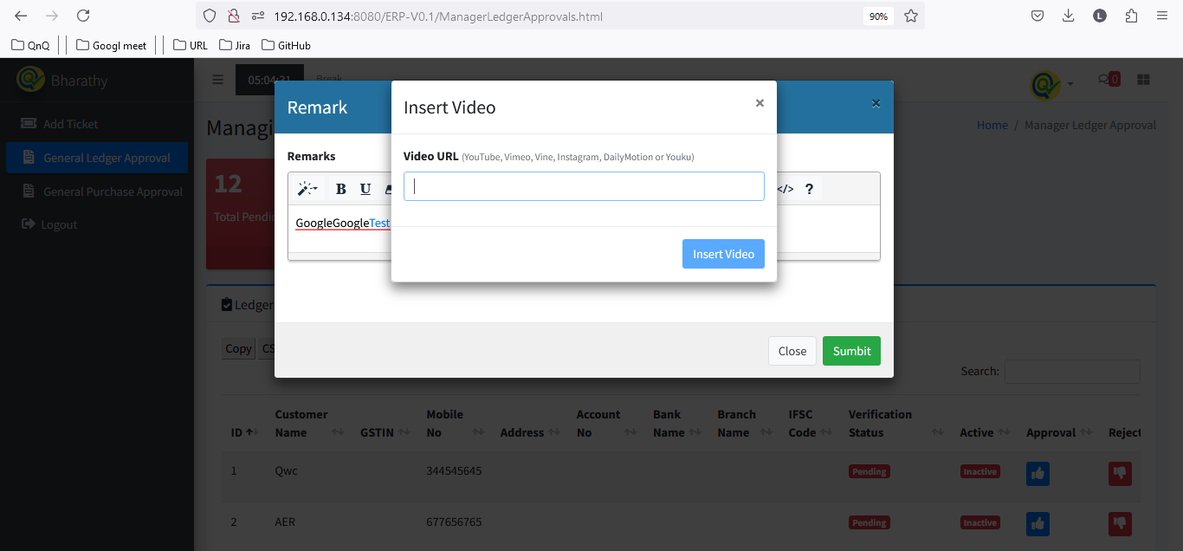 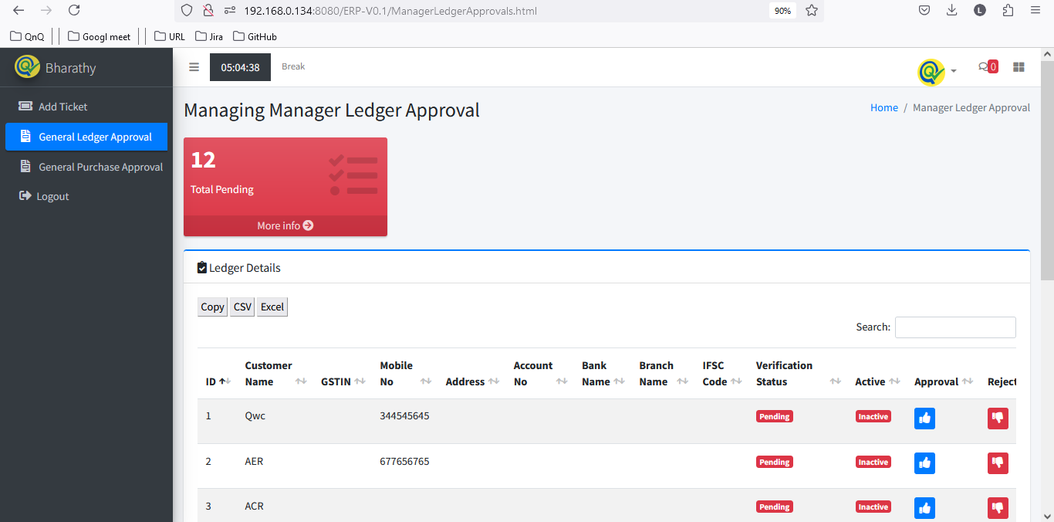

//

27. New URL getting load when uncheck the open in new window 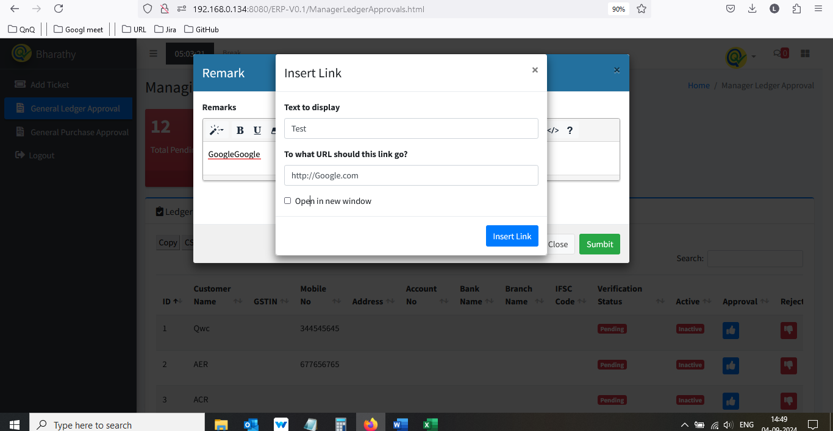 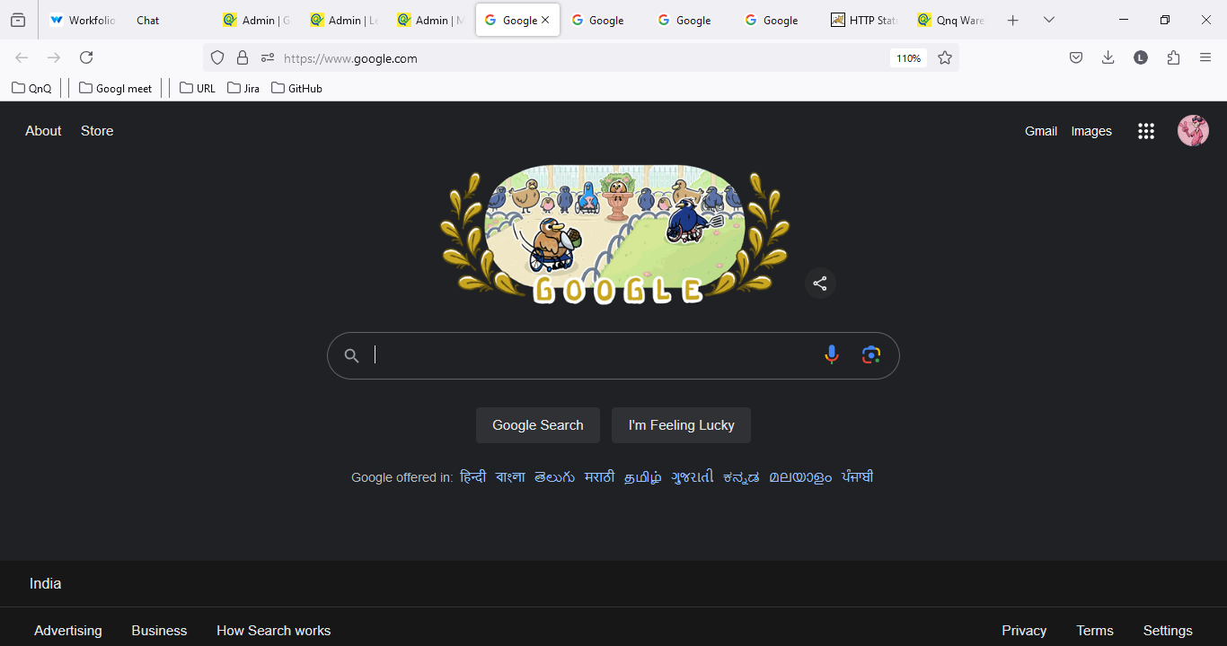

//

28. Given URL not getting clear while unlink the URL 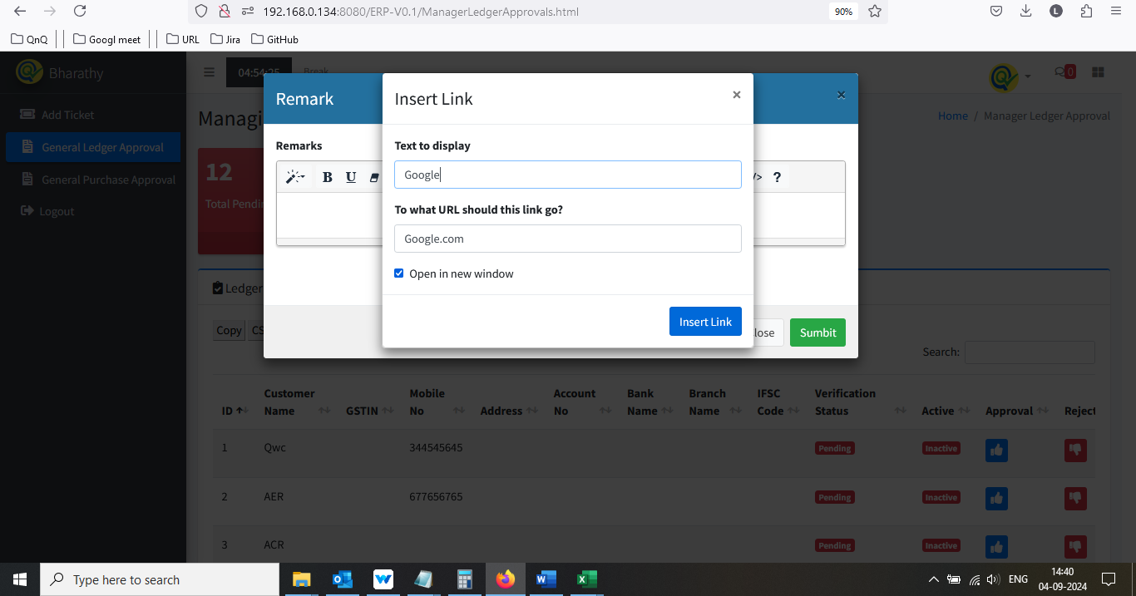 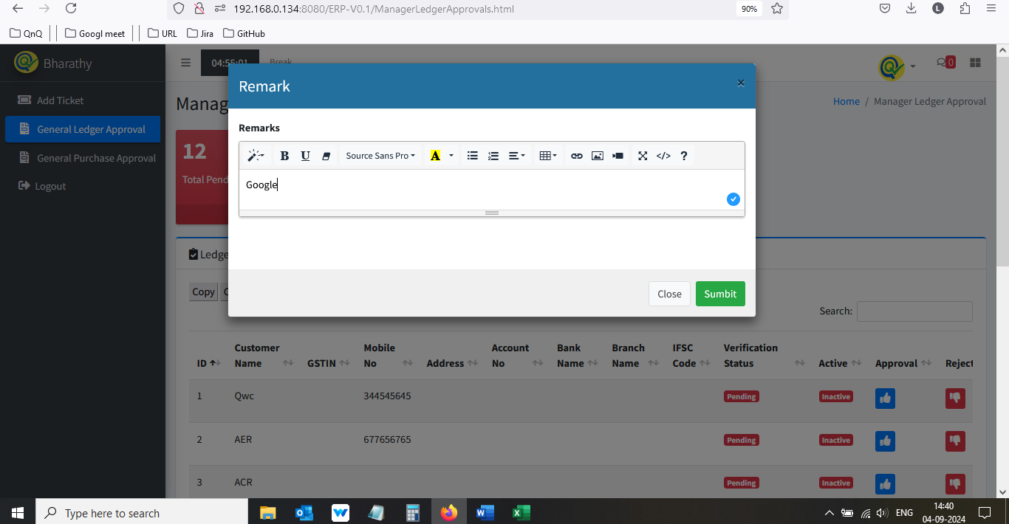 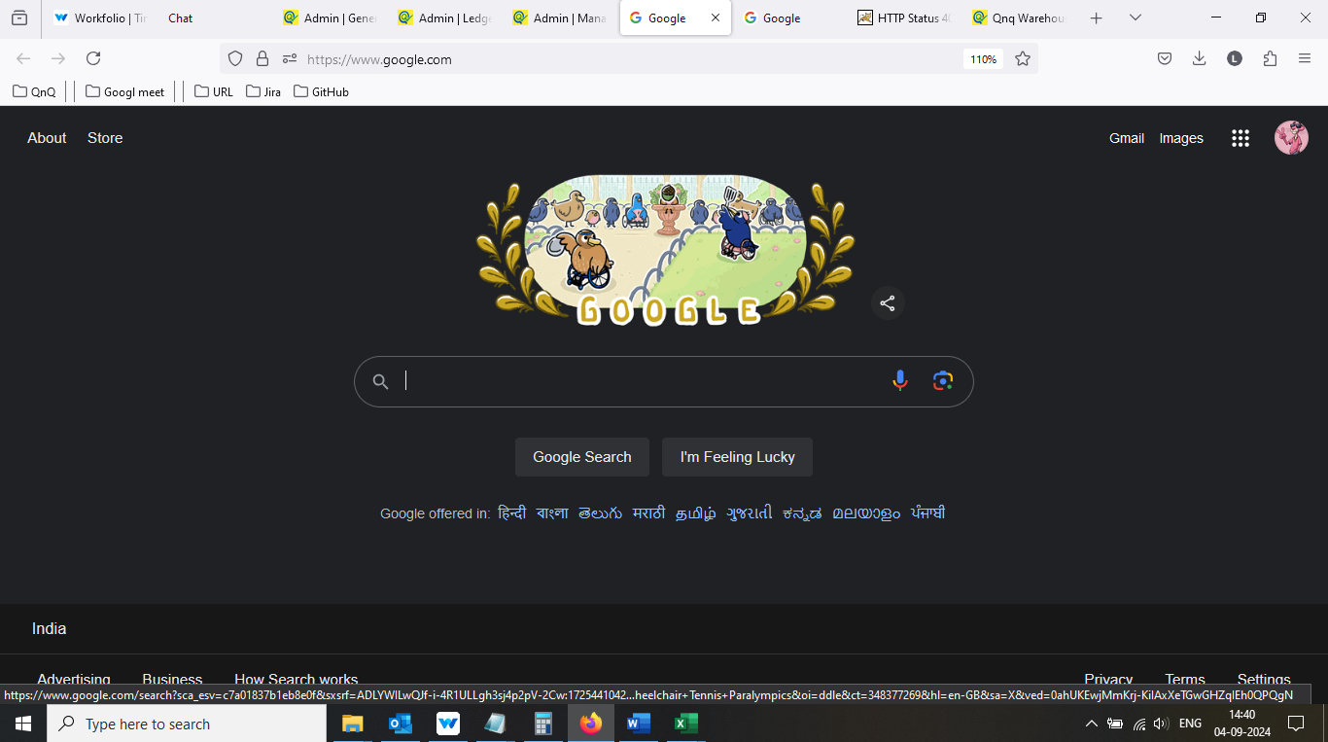 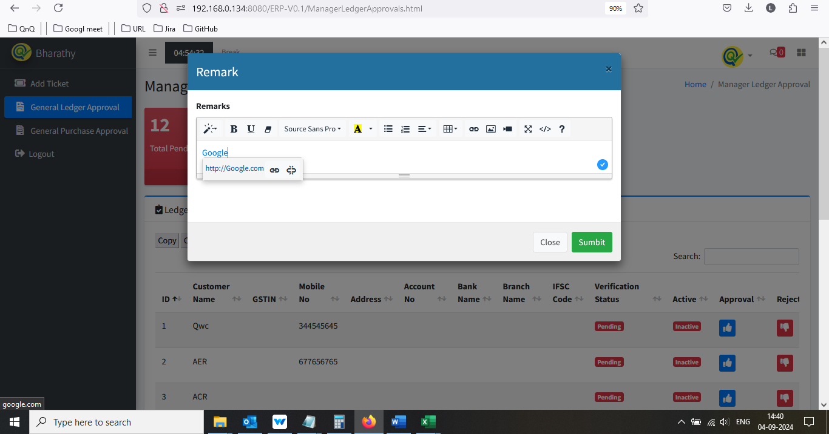 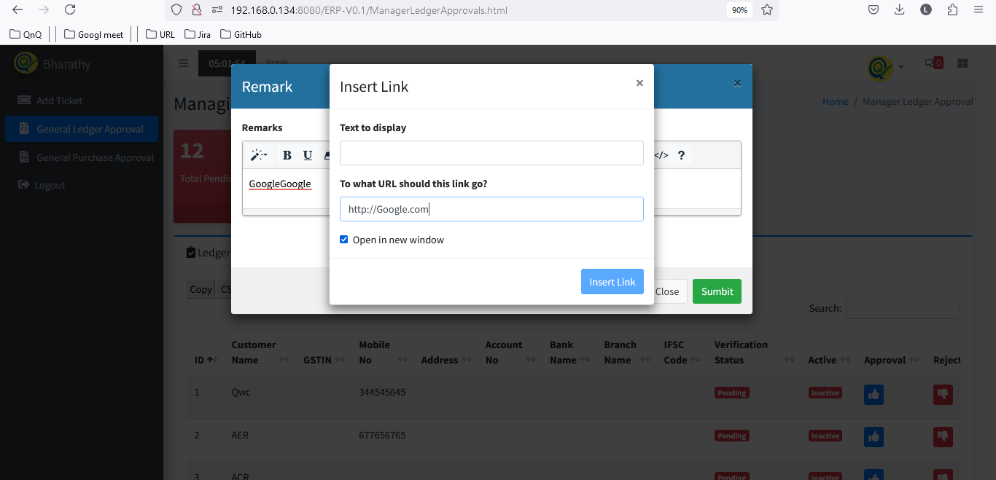 //

29. Video/Image/Link pop up getting close without click close icon 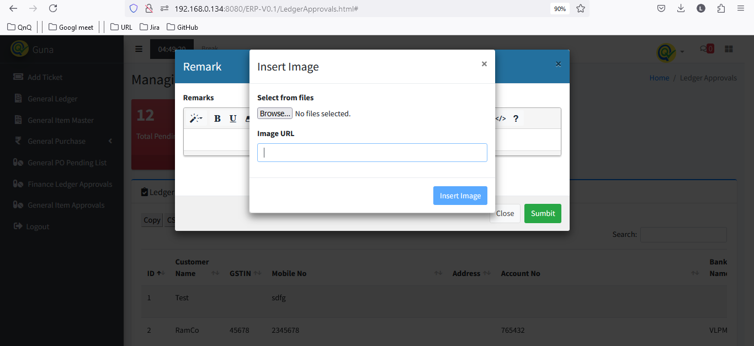 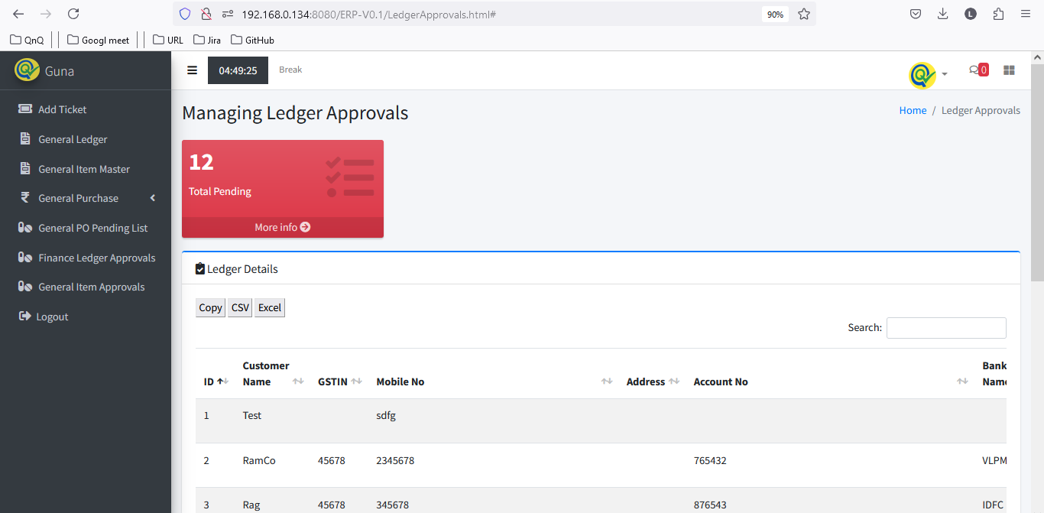

//

30. Given video link not display in Item Remarks field 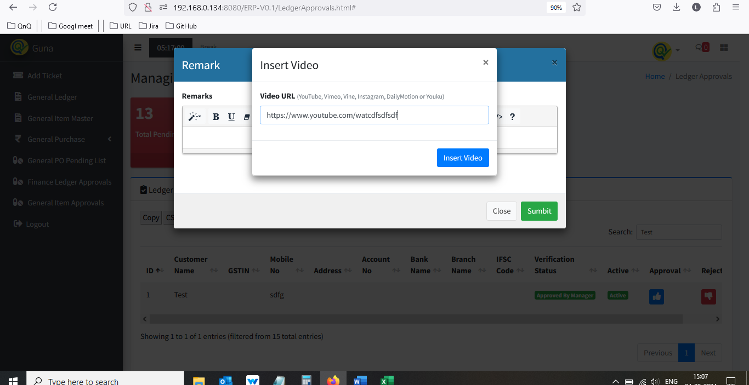 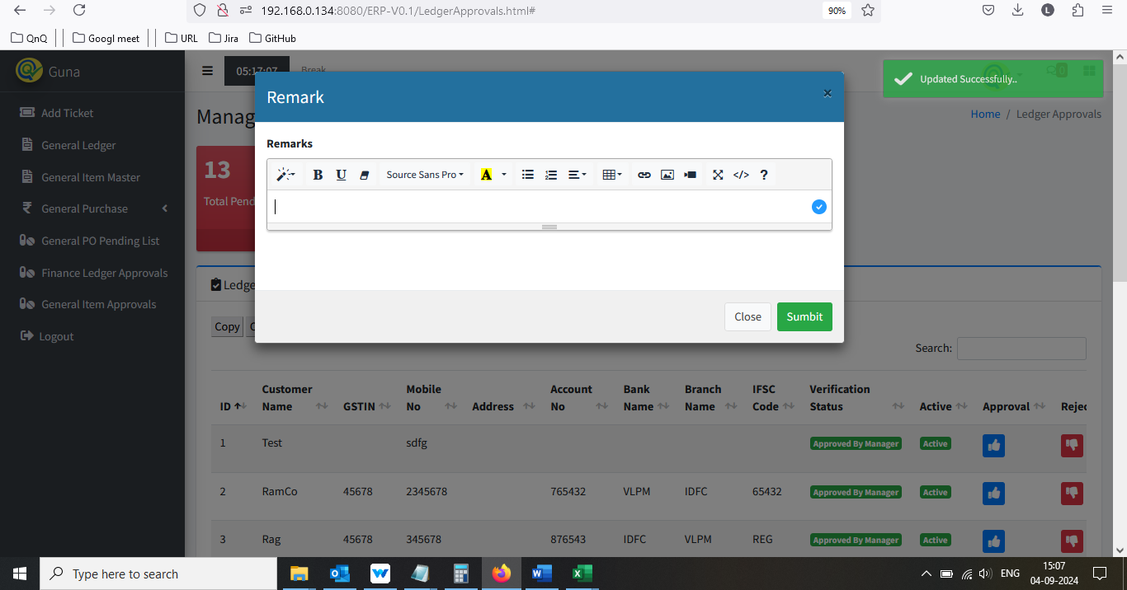

//

31. Unwanted field display while drag and drop any value in Remarks field 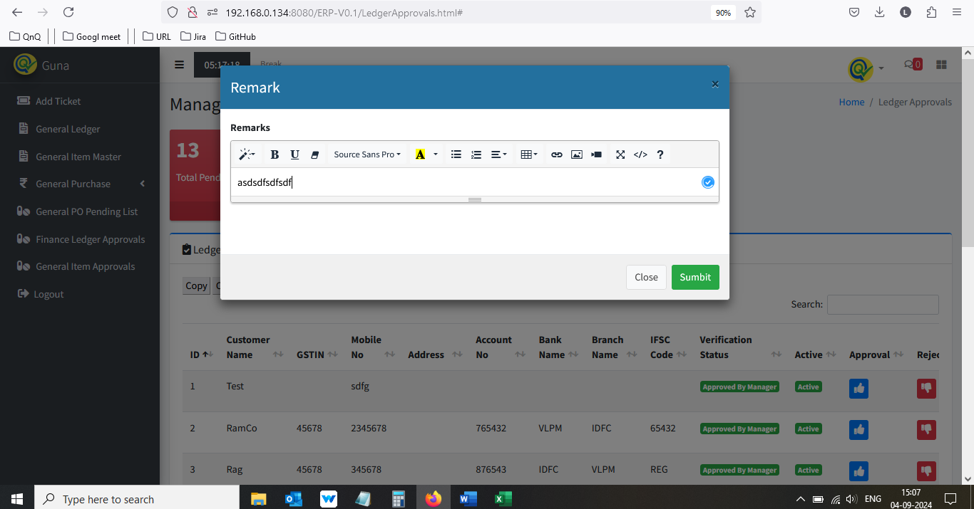 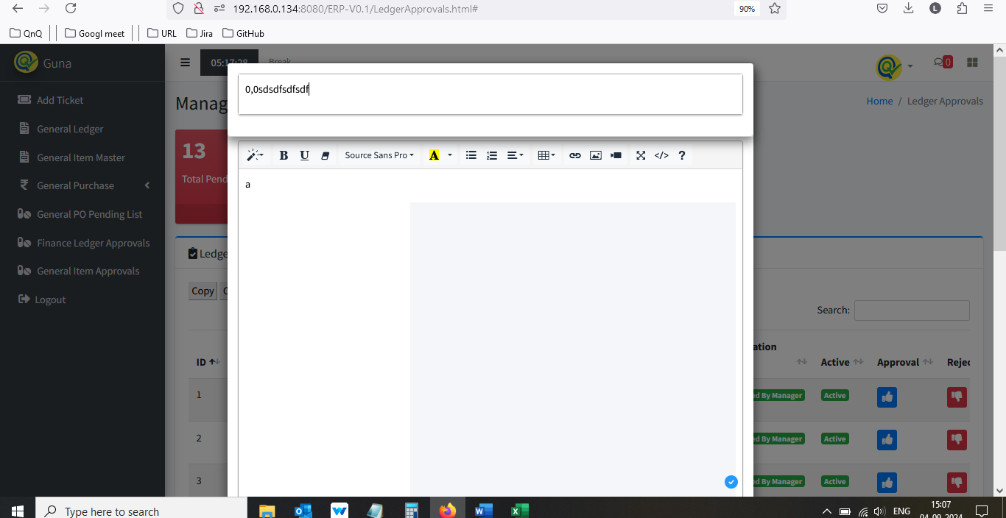

//

32. Approved record not display in Finance Ledger Approval list grid 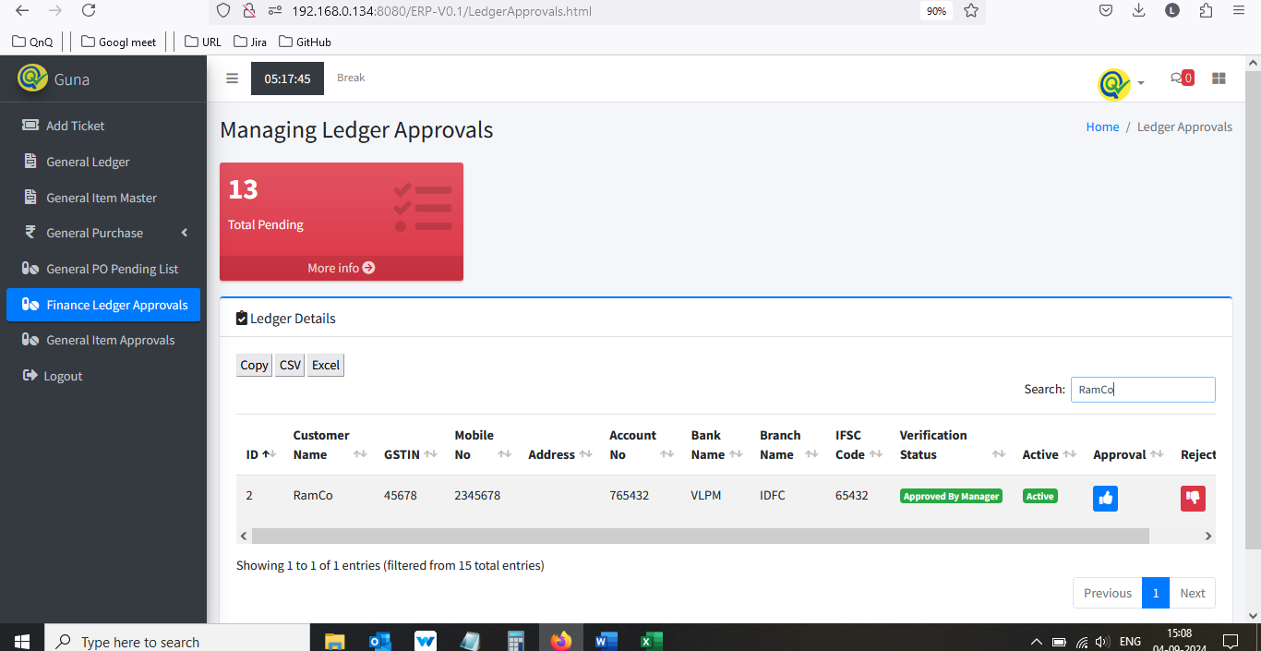 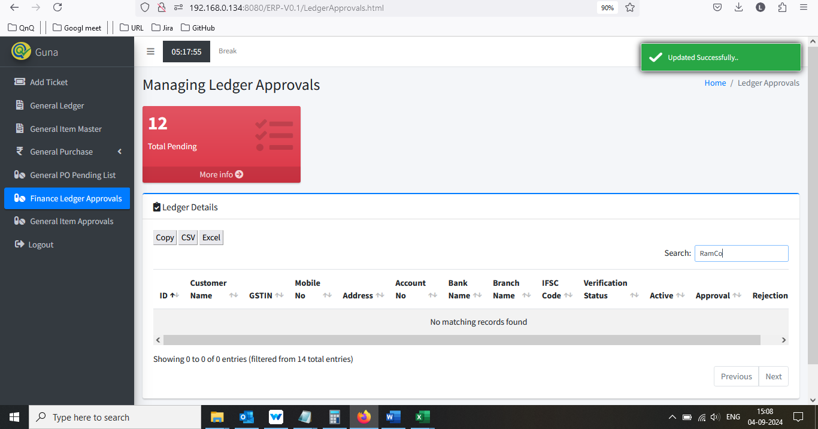

//

33. User can able to submit the rejection pop up with space value alone 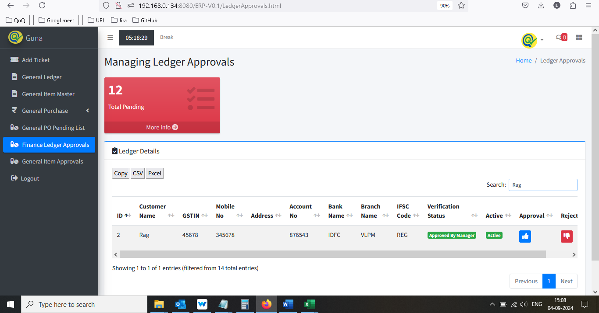 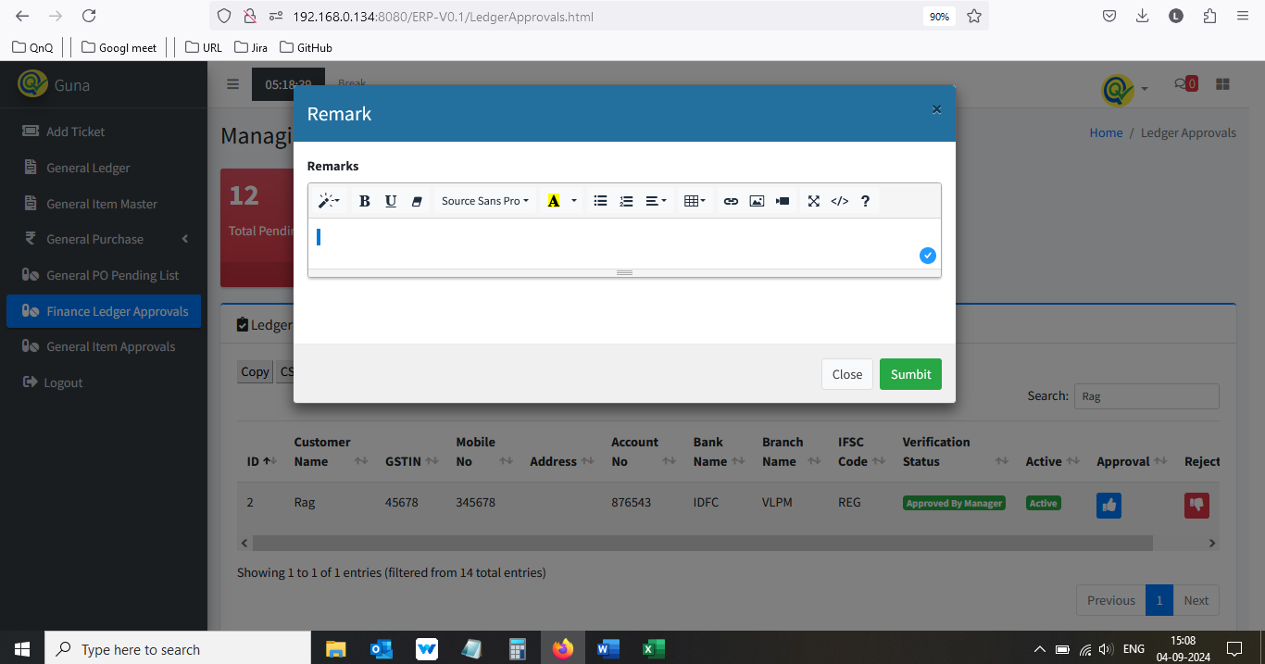 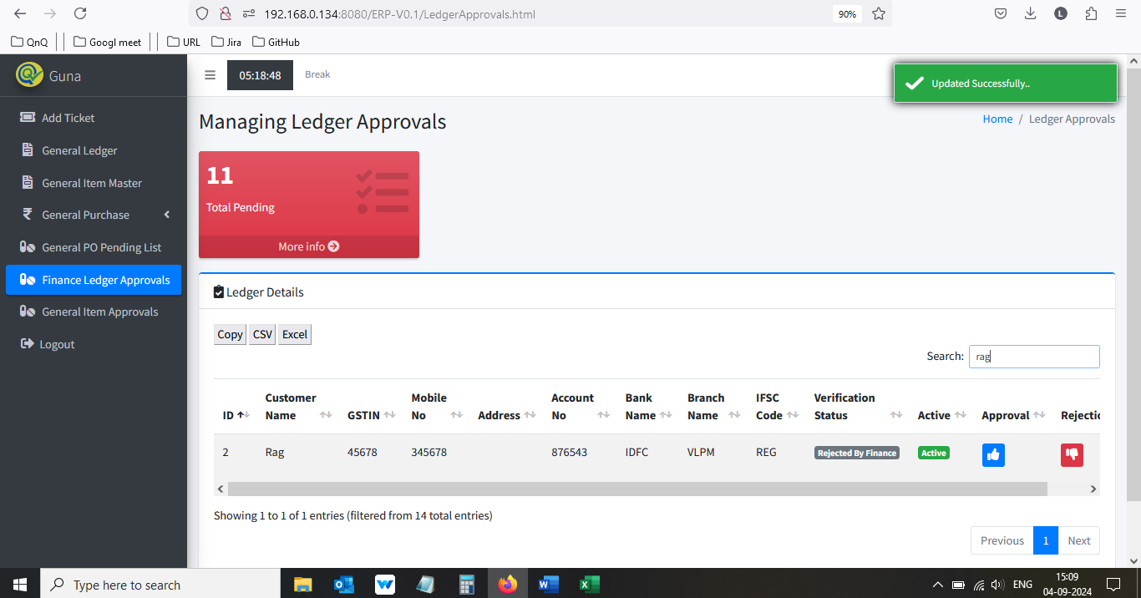

//

34. Mismatch column name display in Finance Ledger Approval list grid 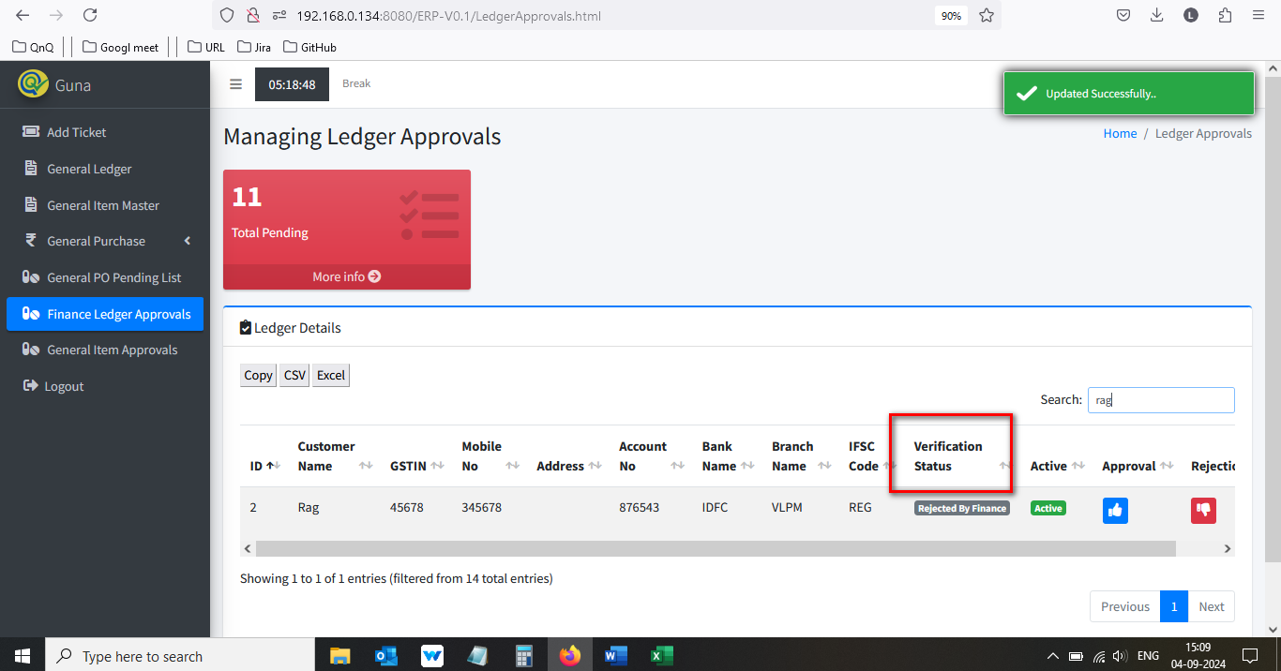

//

35. Approved success message display mismatch content  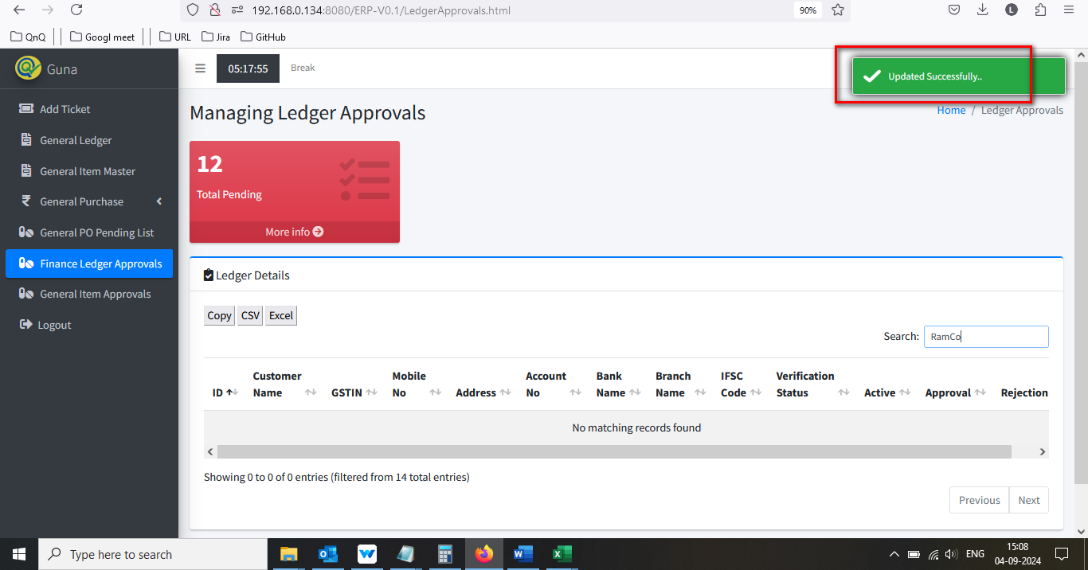

//

36. Rejected success message display mismatch content   

//

37. System allow to perform reject the same record for multiple time  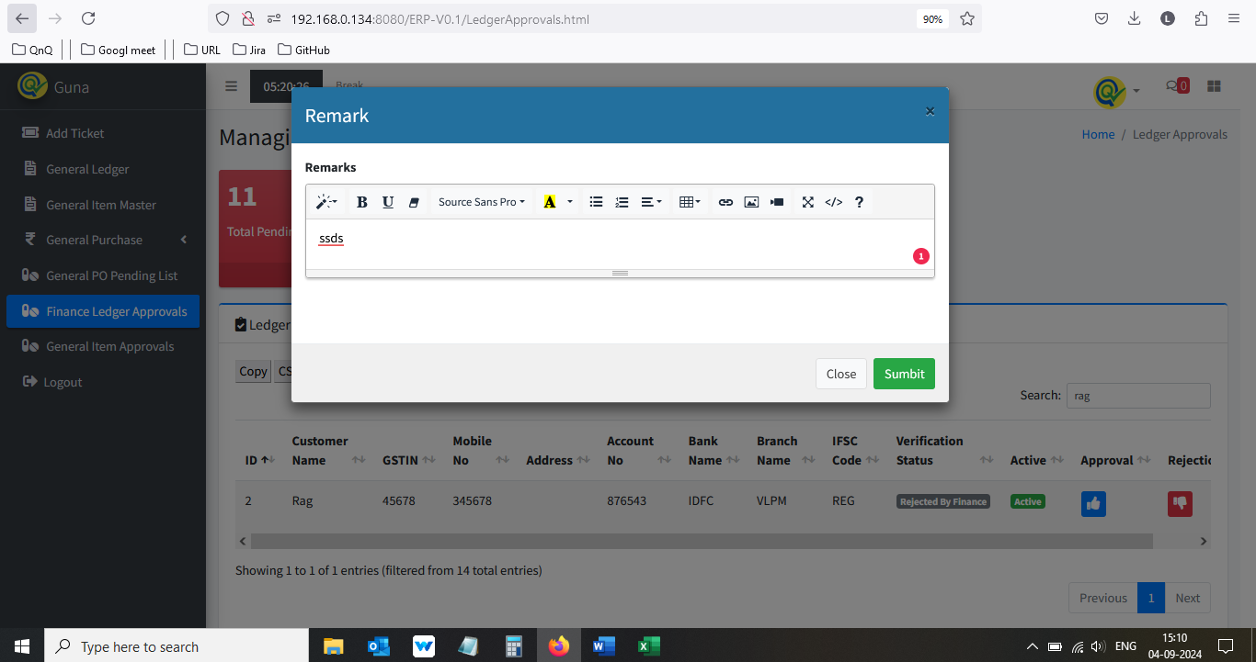 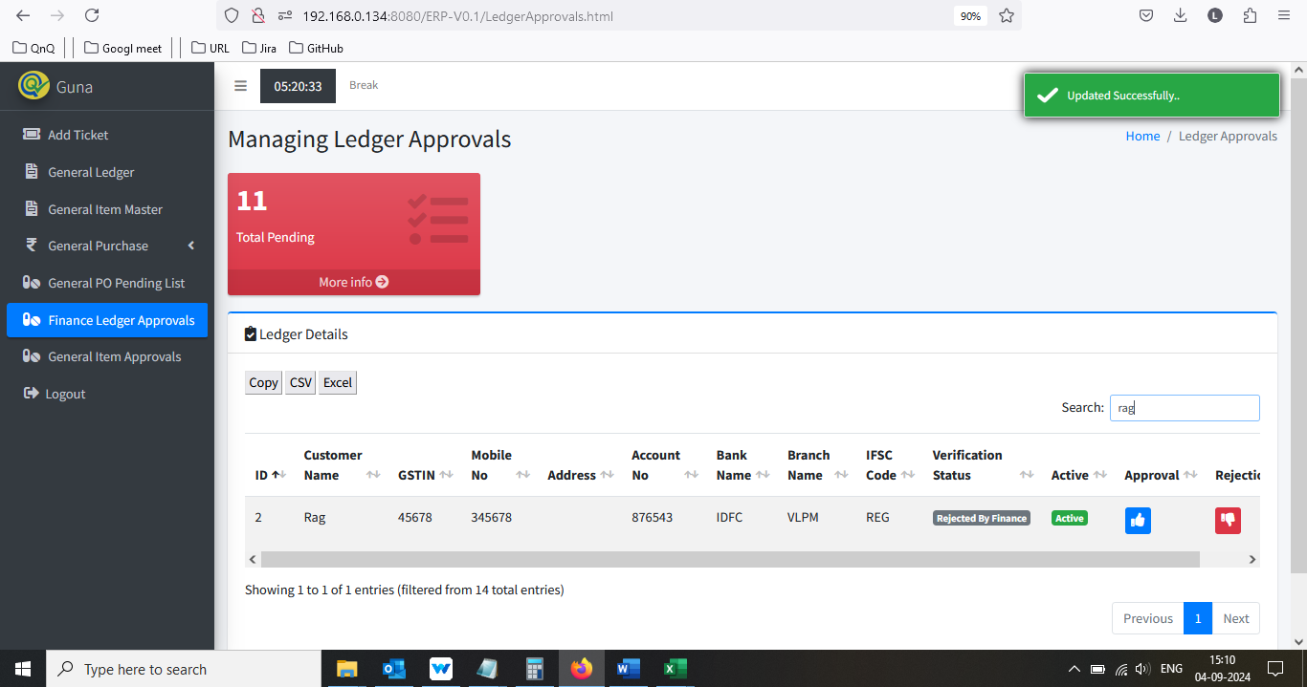

//

38. Showing count dropdown not display in in Finance Ledger Approval page 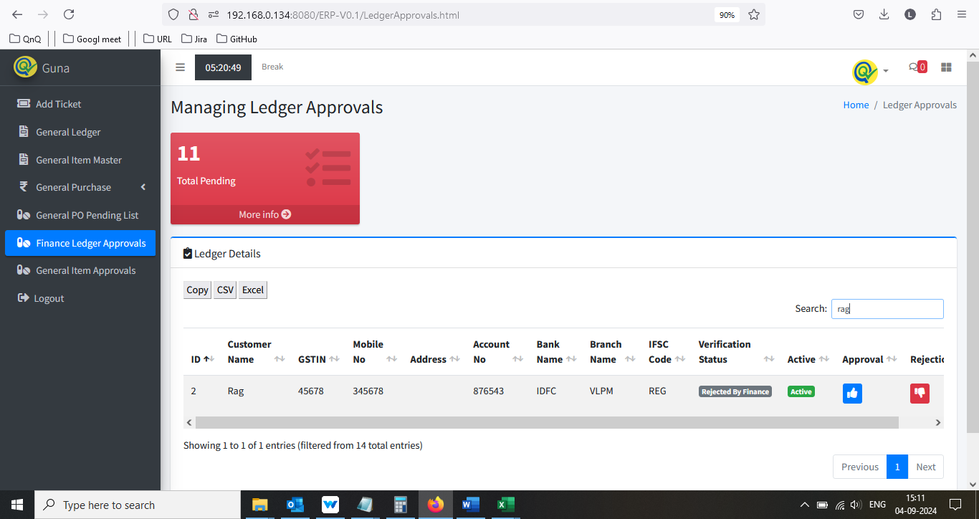

//

39. Mismatch list grid name display in Finance Ledger Approval page 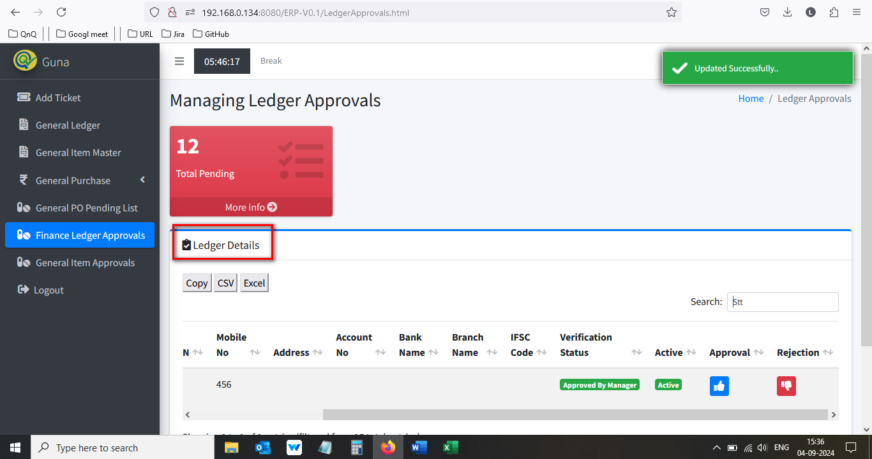

//

40. Error message display while open the Finance Ledger Approval CSV file 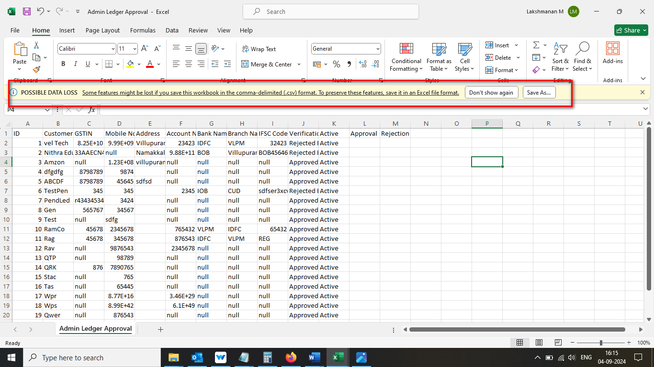

//

41. Null value display while open the Finance Ledger Approval CSV file 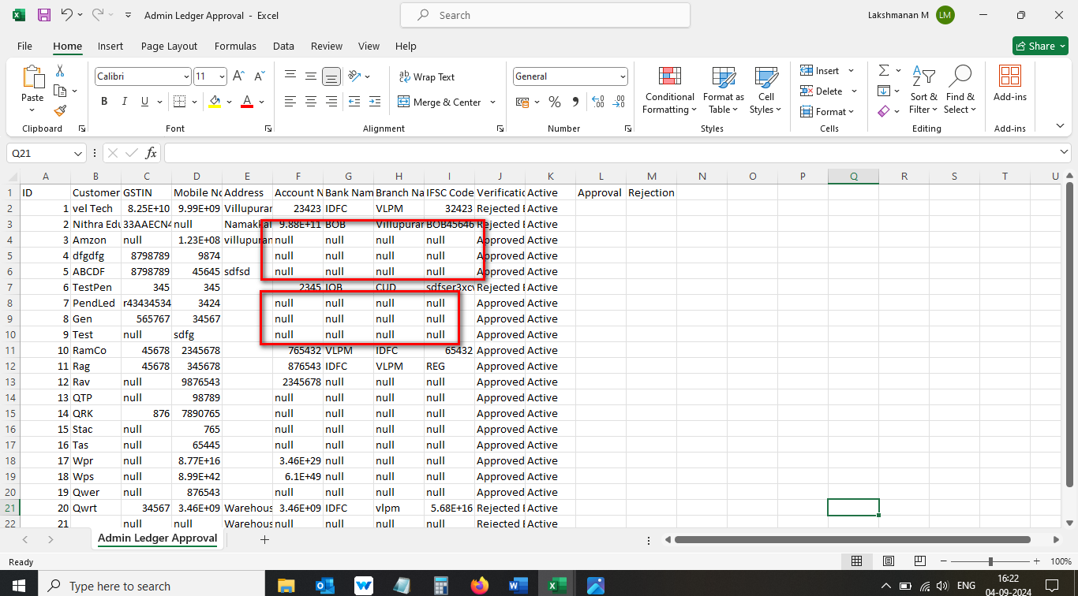

//

42. Header column not display properly in Finance Ledger Approval CSV file 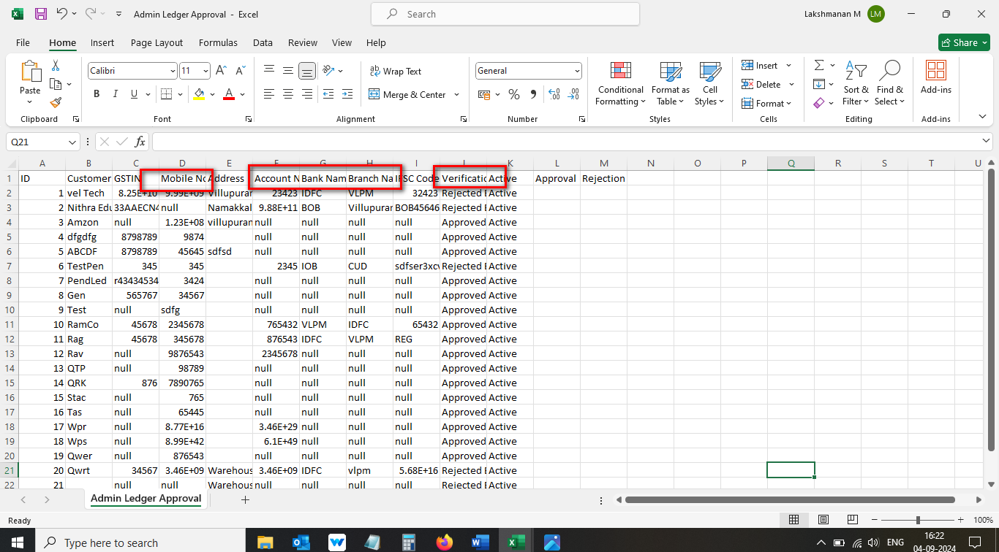

//

43. Header column display as normal column in Finance Ledger Approval CSV file 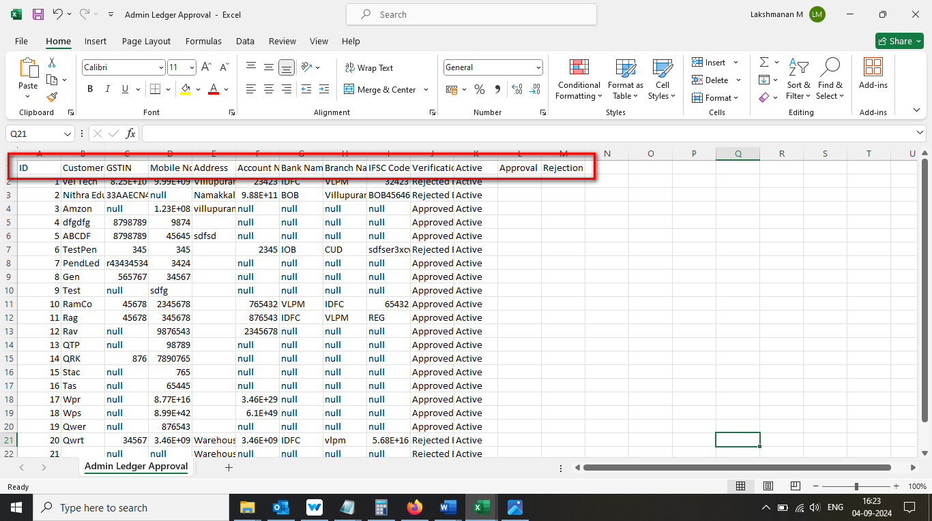

//

44. Given value not display properly in Finance Ledger Approval CSV file 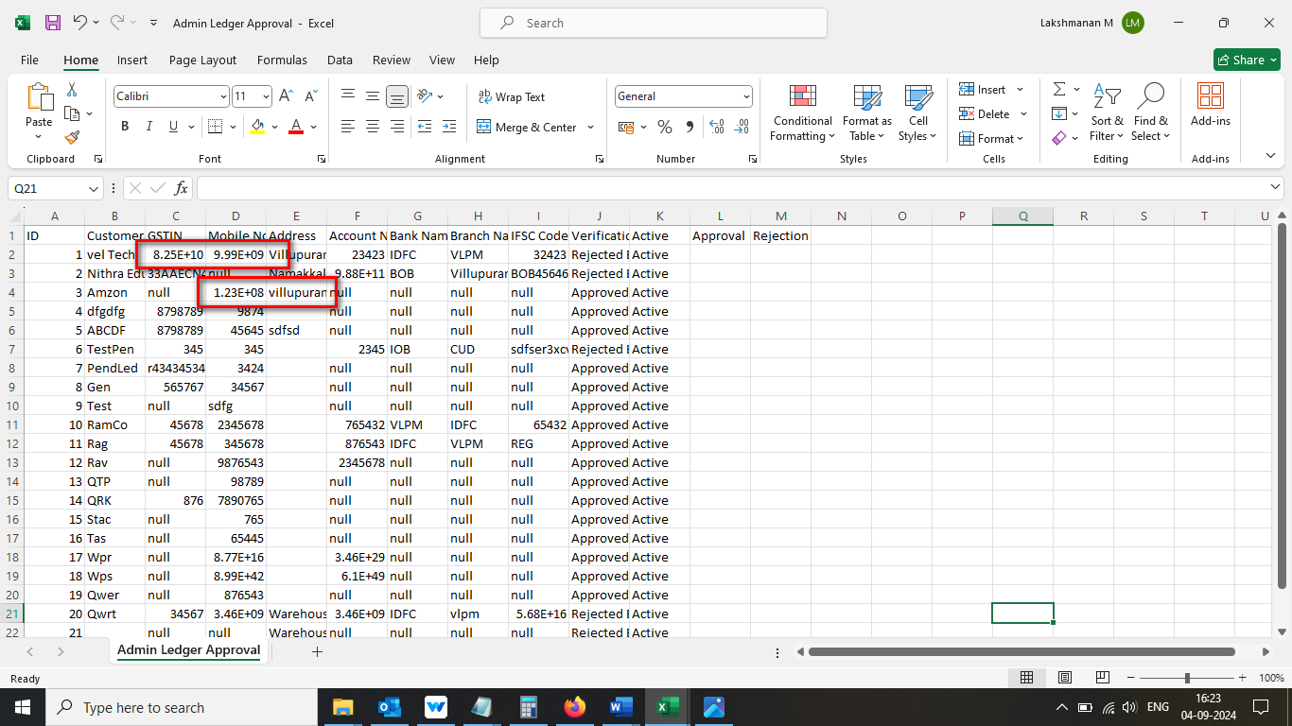

//

45. Unwanted column display in Finance Ledger Approval CSV/Excel file 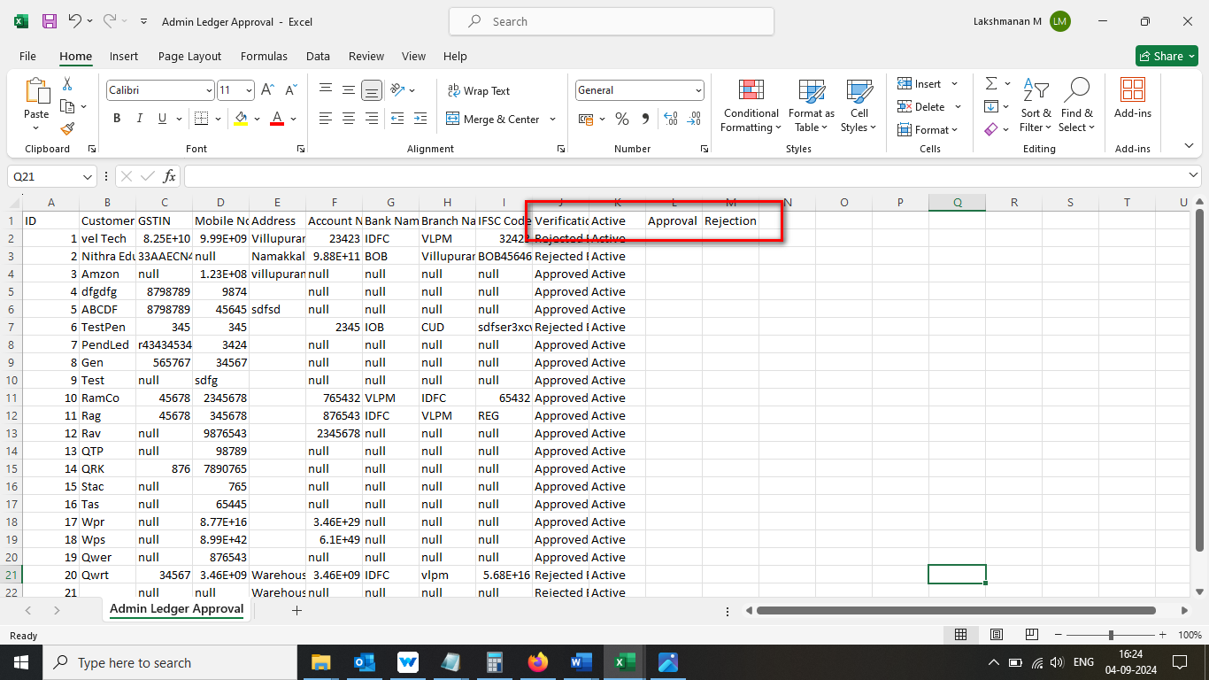

//

46. Sheet name display with number in Finance Ledger Approval CSV file 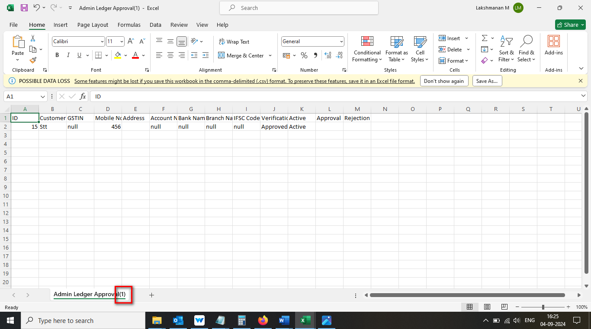

//

47. Improper alignment display in Finance Ledger Approval Excel file 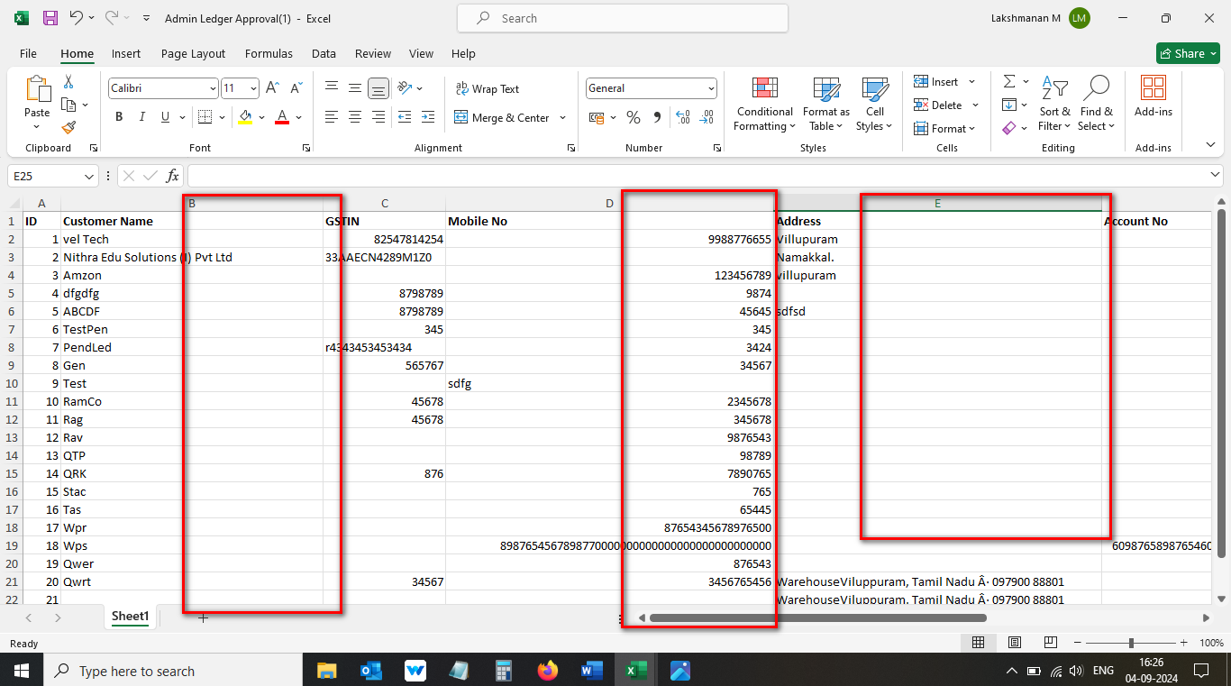

//

48. Mismatch sheet name display in Finance Ledger Approval Excel file 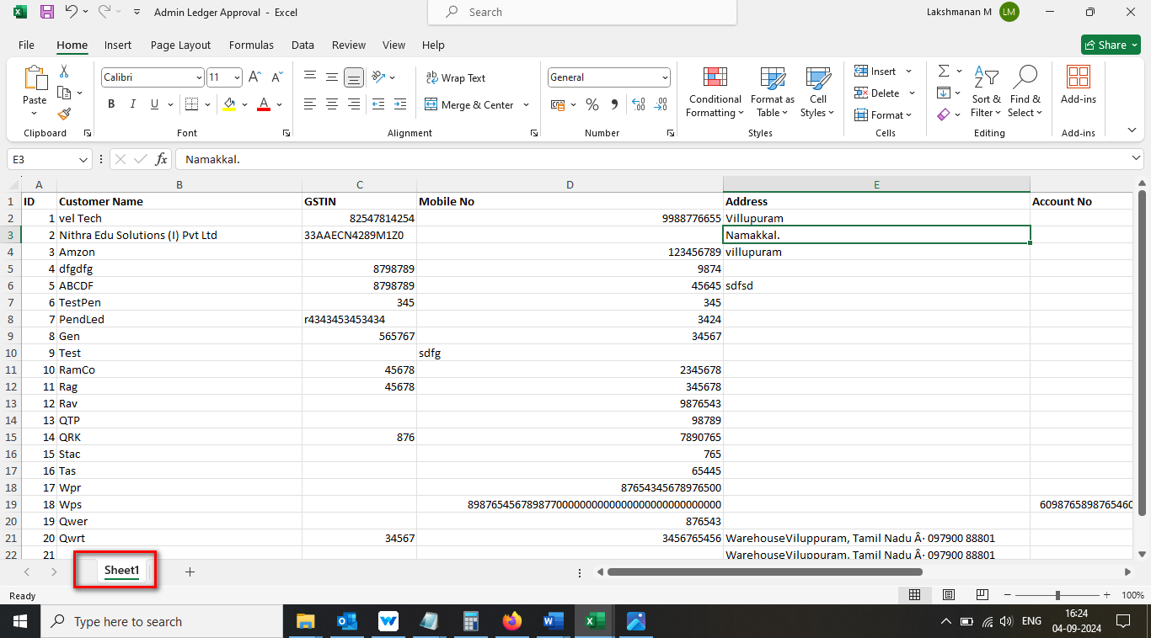

//

49. Mismatch name display for downloaded file 

